SHARPHILL WOOD FLORA SURVEY 2026
Introduction
This report summarises the results from a survey of the flora observed in Sharphill Wood during a number of visits made in 2026; the report follows similar surveys carried out by the author in the nine previous years, 2017-2025.

Sharphill Wood is a native mixed, primarily deciduous, woodland and a designated Local Wildlife Site for its important flora and fauna; it was declared a Local Nature Reserve in 2010. In terms of flora, the canopy of the wood comprises large mature Ash (Fraxinus excelsior), Oak (Pedunculate (Quercus robur) and Sessile (Quercus petraea)), Lime (Tilia x europaea) and Beech (Fagus sylvatica), with a range of other species in the understorey layer and at ground level. Around the wood is a species-rich field margin. The soil has been described by others as comprising a small portion of sand and gravel to the North Westerly corner of the wood, whilst the remainder is heavy red clay; the pH has similarly been described as variably neutral to slightly acidic, registering between 7.0 and 5.6. Generally, the woodland has a diverse structure. In September 2026, the woodland owner (Rushcliffe Borough Council), began a programme of felling ash trees suffering with ash dieback, primarily in Zone 5 (see Appendix 1) where greater than 50% of the crown is reported to be showing decline, and a programme of wider thinning within the woodland, to create space for optimum tree growth and species diversity.
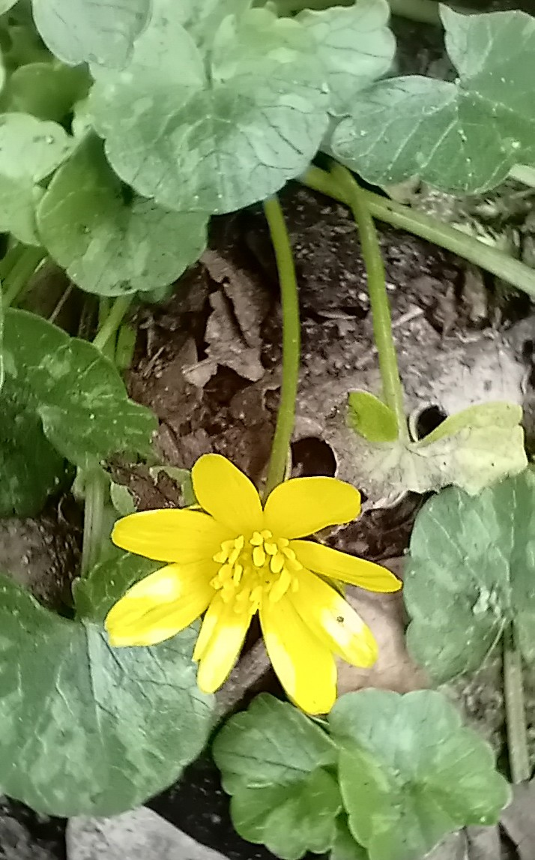

Lesser Celandine, Ranunculus ficaria, at Sharphill Wood

Scope and Methodology
The data in this report are based on 11 visits to the wood, made between 22nd February and 13th October 2026. Each visit lasted between 2 and 3 hours; the time of day varied, although most visits were made in the morning. The survey methodology adopted in the previous nine years concentrated on covering, as far as possible, all areas of the wood at some point during each annual survey; because of the large survey areas involved, the precise transects taken on any particular visit varied (thus, for example, a specific transect might only be covered on alternate visits). For this, tenth, annual survey by the author, the methodology was modified, by adapting an approach described by the Botanical Society of Britain & Ireland (BSBI) for a plant phenology project. Specifically, a fixed route through and around the wood was chosen, covering all 5 zones in the wood and most of the species-rich field margin to the south and west. The route was divided into 7 transects, of varying length but with each transect averaging around 500 metres, locating the start and end point of each section close to obvious features for ease of relocation (a plan of the wood, showing the 5 zones and the 7 transects, with Ordinance Survey grid references for the start and end point of each, is reproduced in Appendix 1). This fixed route was walked at approximately 3-week intervals in the main flowering period between March and August, noting species which were present at any particular time within around 2.5 metres either side of the chosen route.

As part of mitigation measures associated with the ongoing housing development to the north and east of the wood, a post and rail fence encircling the wood was constructed in the summer of 2018. Following this, a 30-metre wide ‘buffer’ zone in between the post and rail fence and the housing development was planted up by the developers in autumn 2018, on land (formerly agricultural) adjoining the north and east boundaries of the wood. This planting is described on the developer’s landscape plans as comprising ‘woodland edge core’ species, for example Pedunculate Oak and Field Maple, and ‘woodland edge’ species, for example Hawthorn and Dog-rose. In addition, since 2018, a range of other species have populated the buffer zone at ground level. However, the extent of this flora survey was limited to the wood itself and the immediate southern and western boundaries outside the wood; specifically, including the post and rail fence but not the buffer zone. In parts, the buffer zone planting is now so well established that access to the northern and eastern boundaries outside the wood is challenging at the height of the growing season, and these boundaries have been excluded from this and future surveys.

Identification was generally based on the observed flower, aided by other salient botanical features such as leaf, stem and fruit, where appropriate. Reference was also made to the expected flowering period and geographical distribution, as detailed in two reference documents: (1) ‘The Wild Flower Key’, Francis Rose, 2006, for wild flowers and trees, and; (2) ‘Collins Pocket Guide. Grasses, Sedges, Rushes and Ferns of Britain and Northern Europe’, R. Fitter, A. Fitter and A. Farrer, 1984, for grasses, sedges, rushes and ferns. The survey also drew on the list of species previously identified.
Based on the above methodology, a particular species was simply recorded as present on a spreadsheet; each record comprises the first confirmed sighting of the year for that particular species. The confirmed sighting would normally be triggered by the first observation in that year of a prominent botanical feature, typically the flower. Subsequent sightings of a particular species (for example, elsewhere in the wood on the same visit, or on a different visit at a different time) were not recorded; because of the size and complexity of the task, no attempt was made to categorise frequency (for example, by a ‘DAFOR’ scale), or to indicate distribution locally within the wood. The methodology used is not precise and on any particular visit some species may have been missed for a variety of reasons, such as missing the flowering period, not being in the right place at the right time, inexperience and/or simply a failure of observation. All visits were made by the author.
Results
The species recorded during the 2026 survey are listed in alphabetical order in Appendix 2 at the end of this report. The complete data from the 2026 and previous surveys by the author are located in worksheet ‘2017-26’ in the accompanying Excel Spreadsheet: ‘Flora Survey_2026_NC’. The Excel Spreadsheet includes all flora species which have been documented in Sharphill Wood from 2001 until the present time. A confirmed sighting of any particular species in 2026 is identified on the worksheet by an entry of ‘26’ in column K (entitled ‘2026’). The data from the previous nine years are shown alongside column K, in columns B to J, using a similar methodology. The results from surveys carried out by others, in 2015 and before, are located in a separate worksheet entitled ‘2001-15’. From 2021, a 3rd worksheet was included in the spreadsheet detailing the actual date on which the sighting was made (see below for further details). This additional information was included so that the data could be input onto Nature Counts (NC), an online recording system for wildlife sightings which Nottinghamshire Wildlife Trust started using in 2021 and for which the actual sighting date is required information: (https://record.nottinghamshirewildlife.org/#:~:text=About,Nature%20Recovery%20strategy%20in%20Nottinghamshire).
This information is required to be input onto NC once only for each species identified; accordingly, from 2021 onwards, the date of the first sighting of each species has been recorded on this 3rd worksheet, suffixed ‘NC’. Most Sharphill Wood species are now input onto NC. However, for any ‘new’ species sighted for the first time in 2026, the 3rd worksheet, entitled ‘2026 NC’, would contain the same ‘new’ 2026 species sightings as in worksheet ‘2017-2026’, but with the actual date of the sighting recorded. For completeness, any sightings first recorded prior to 2021, but not sighted subsequently until the current observation year (and therefore not previously uploaded to NC) would also routinely be entered on this 3rd (‘NC’) worksheet; in 2026, there were no sightings in the latter category, and one ‘new’ sighting.

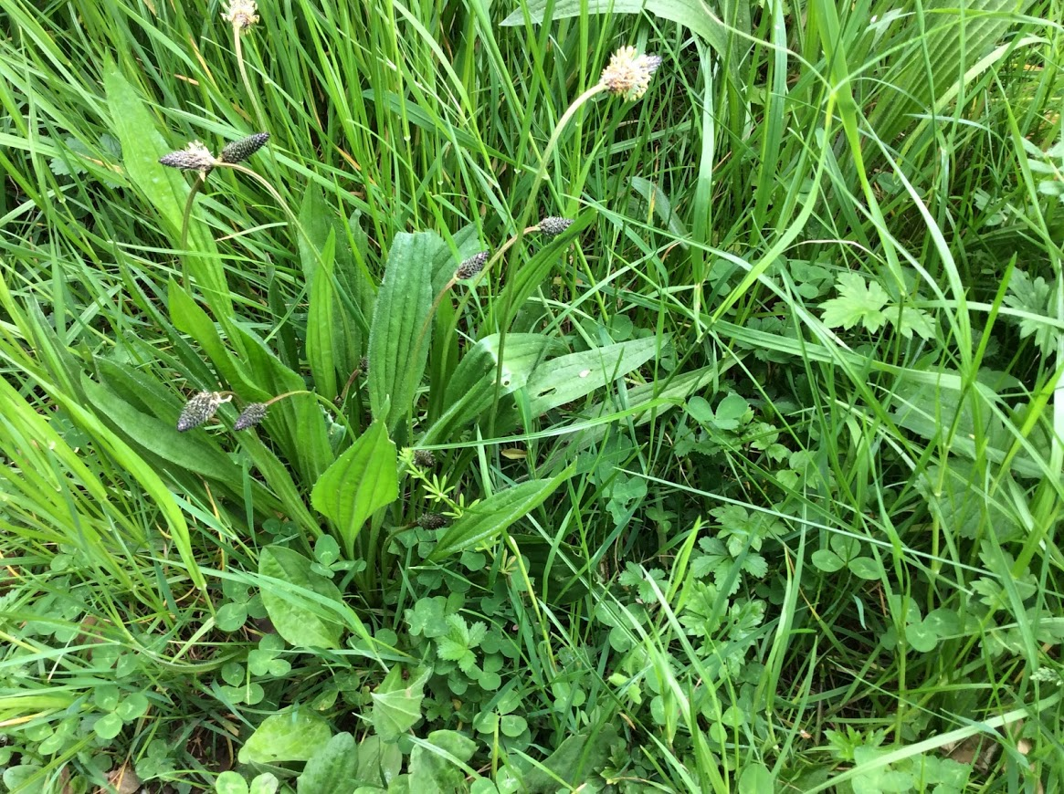

Ribwort Plantain, Plantago lanceolata, at Sharphill Wood

The 2025/2026 winter season was generally very wet with frequent rainfall and cool/cold weather. January and February 2026 were characterised by lots of grey days and little sunshine, making it feel cool. March started drier, mild and sunny, and early spring was characterised by a mixture of mild, sometimes wet, sometimes sunny weather. The 2026 spring and summer was generally very dry, and the weather turned warm in May with several hot/very hot spells in May/June and June/July. Hotter, drier weather dominated from late June until early September, with more variable weather for the late summer and early autumn.

Commentary and Conclusions
The reader is referred to Appendix 2 below for details of the individual plants identified in 2026 (and to the accompanying Excel Spreadsheet: ‘Flora Survey_2026_NC’ for the complete data from the 2026 and previous surveys). In summary, 86 species of wildflower, 30 species of tree and 17 species of grass, sedge, rush and fern were identified in 2026 (a total of 133 species), including one not previously recorded. As in previous surveys, some species which have been recorded in earlier years were not identified in 2026 (these are shown by a blank entry in column K). It is likely that the reasons for this include the observational issues outlined above, species variability and the ongoing development. However, a small reduction in wildflower numbers can be seen when compared with the 2024 and 2025 surveys; it is likely that the fixed route adopted for the 2026 survey, and the exclusion of the northern and eastern boundaries outside the wood, have contributed to this reduction, rather than being indicative of any significant change in composition.

Richard Elliott, on behalf of Friends of Sharphill Wood.
appendix 1

sharphill wood plan showing zones, fixed survey route and numbered transects

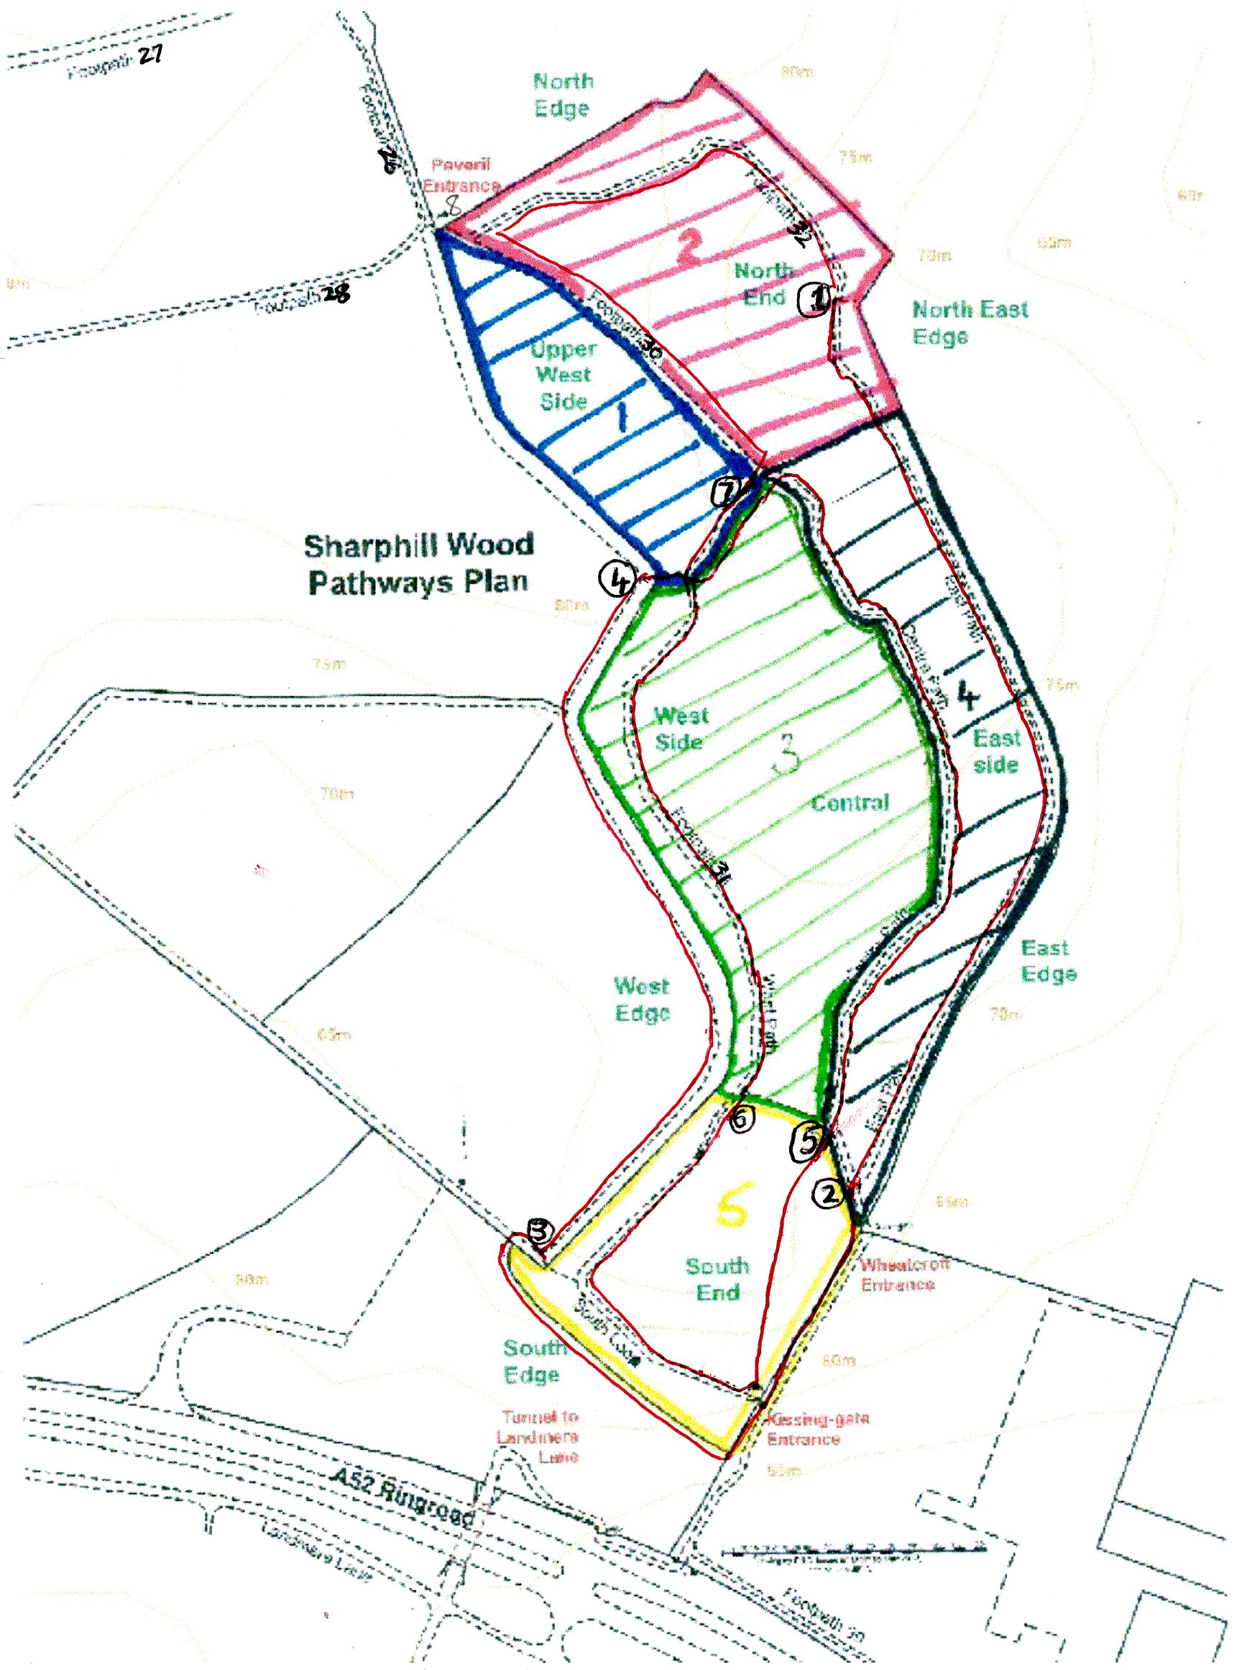

Explanatory Notes to Sharphill Wood Plan
The coloured hatching and accompanying numbers 1 to 5 on the plan relate to the 5 zones which are used by the Friends of Sharphill Wood for referencing purposes.

The fixed route adopted for this survey is shown as a red line on the plan. The route starts at the number ① (denoting the start of the 1st transect); the 2nd transect starts at the number ②, and so on. The last, 7th, transect similarly starts at the number ⑦ and finishes at the start point (number ①). The Ordinance Survey grid references for the start and end point of each transect are shown in Table A1 below.

Transect Number | Grid Ref OS Easting | Grid Ref OS Northing
① | 5867 | 3508
② | 5867 | 3464
③ | 5851 | 3462
④ | 5857 | 3493
⑤ | 5865 | 3466
⑥ | 5861 | 3469
⑦ | 5861 | 3498

Table A1: Ordinance Survey grid references for the start and end point of each transect

APPENDIX 2

SPECIES RECORDED DURING SHARPHILL WOOD FLORA SURVEY 2026
Wild Flower Species Recorded as Present, 2026
Agrimony (Agrimonia eupatoria)
Anemone, Wood (Anenome nemorosa)
Avens, Wood (Geum urbanum)
Bindweed, Field (Convolvulus arvensis)
Bluebell, Spanish (Hyacinthoides hispanica)
Bluebell (Hyacinthoides non-scripta)
Bramble (Rubus fructicosus)
Bryony, Black (Tamus communis)
Bryony, White (Bryonia dioica)
Burdock, Lesser (Arctium minus)
Buttercup, Bulbous (Ranunculus bulbosus)
Buttercup, Creeping (Ranunculus repens)
Buttercup, Meadow (Ranunculus acris)
Campion, Bladder (Silene vulgaris)
Campion, Red (Silene dioica)
Cat's-ear (Hypochaeris radicata)
Celandine, Lesser (Ranunculus ficaria)
Charlock (Sinapis arvensis)
Chickweed, Common (Stellaria media)
Cleavers (Galium aparine)
Clover, White (Trifolium repens)
Cowslip (Primula veris)
Crane's-bill, Cut-leaved (Geranium dissectum)
Crane's-bill, Dove's-foot (Geranium molle)
Crane's-bill, Pencilled (Geranium versicolor)
Crocus, Spring (Crocus vernus)
Cuckoo-pint (Arum maculatum)
Currant, Flowering (Ribes sanguineum)
Daisy (Bellis perennis)
Daisy, Oxeye (Leucanthemum vulgare)
Daffodil (Narcissus pseudonarcissus)
Dandelion (Taraxum agg)
Dead Nettle, Red (Lamium purpureum)
Dead Nettle, White (Lamium album)
Dock, Broad Leaved (Rumex obtusifolius)
Dock, Clustered (Rumex conglomeratus)
Dock, Curled (Rumex crispus)
Dock, Wood (Rumex sanguineus)
Dog-violet, Common (Viola riviniana)
Dog-violet, Early (Viola reichenbachiana)
Enchanters Nightshade (Circaea lutetiana)
Forget-me-not, Early (Myosotis ramosissima)
Forget-me-not, Field (Myosotis arvensis)
Ground-ivy (Glechoma hederacea)
Groundsel (Senecio vulgaris)
Hawkweed (Hieracium agg)
Hedge-parsley, Upright (Torilis japonica)
Hemlock (Conium maculatum)
Herb-Robert (Geranium robertianum)
Hogweed (Heracleum sphondylium)
Honesty (Lunaria annua)
Honeysuckle (Lonicera periclymenum)
Ivy (Hedera helix)
Knotgrass (Polygonum aviculare)
Mayweed, Scented (Matricaria recutia)
Mugwort (Artemisia vulgaris)
Mustard, Garlic (Alliaria petiolata)
Mustard, Hedge (Sisymbrium officinale)
Nettle, Common (Urtica dioica)
Orchid, Early-purple (Orchis mascula)
Oregon-grape (Mahonia aquifolium)
Oxtongue, Bristly (Picris echioides)
Parsley, Cow (Anthriscus sylvestris)
Pineappleweed (Matricaria discoidea)
Plantain, Greater (Plantago major)
Plantain, Ribwort (Plantago lanceolata)
Poppy, Common (Papaver rhoeas)
Ragwort, Common (Senecio jacobaea)
Scabious, Field (Knautia arvensis)
Selfheal (Prunella vulgaris)
Shepherd's-purse (Capsella bursa-pastoris)
Snowdrop (Galanthus nivalis)
Sow-thistle, Smooth (Sonchus oleraceus)
Sow-thistle, Prickly (Sonchus asper)
Speedwell, Common Field (Veronica persica)
Speedwell, Germander (Veronica chamaedrys)
Speedwell, Ivy-leaved (Veronica hederifolia)
St John's-wort, Perforate (Hypericum perforatum)
Thistle, Creeping (Cirsium arvense)
Thistle, Spear (Cirsium vulgare)
Vetch, Common (Vicia sativa)
Violet, Sweet (Viola odorata)
Willowherb, Great (Epilobium hirsutum)
Willowherb, Rosebay (Chamerion angustifolium)
Willowherb, Broad Leaved (Epilobium montanum)
Woundwort, Hedge (Stachys sylvatica)

Grass, Sedge, Rush and Fern Species Recorded as Present, 2026
Barley, Wall (Hordeum murinum)
Brome, Barren (Bromus sterilis)
Brome, False (Brachypodium sylvaticum)
Brome, Great (Bromus diandrus)
Brome, Soft (Bromus hordeaceus)
Cocksfoot (Dactylis glomerata)
Couch Grass, Common (Elytrigia repens)
Fern, Broad Buckler (Dryopteris dilatata)
Fern, Male (Dryopteris filix-mas)
Fescue, Meadow (Festuca pratensis)
Meadow-grass, Annual (Poa annua)
Meadow-grass, Rough (Poa trivialis)
Oat-grass, False (Arrhenatherum elatius)
Oat-grass, Yellow (Trisetum flavescens)
Rye-grass, Perennial (Lolium perenne)
Sedge, Pendulous (Carex pendula)
Yorkshire Fog (Holcus lanatus)

Trees Species Recorded as Present, 2026
Ash (Fraxinus excelsior)
Beech (Fagus sylvatica)
Blackthorn (Prunus spinosa)
Cherry, Bird (Prunus padus)
Cherry, Wild (Prunus avium)
Chestnut, Sweet (Castanea sativa)
Crab Apple (Malus sylvestris)
Dog-rose (Rosa canina agg)
Dogwood (Cornus sanguinea)
Elder (Sambucus nigra)
Elm, Wych (Ulmus glabra)
Field-rose (Rosa arvensis)
Guelder-rose (Viburnum opulus)
Hawthorn (Crataegus monogyna)
Hazel (Corylus avellana)
Holly (Ilex aquifolium)
Lime (Tilia x europaea (T. x vulgaris))
Maple, Field (Acer campestre)
Maple, Norway (Acer platanoides)
Oak, Pedunculate (Quercus robur)
Oak, Red (Quercus rubra)
Oak, Sessile (Quercus petraea)
Plum, Cherry (Prunus cerasifera)
Pine, Scots (Pinus sylvestris)
Privet, Wild (Ligustrum vulgare)
Rowan (Sorbus aucuparia)
Spindle (Euonymus europaeus)
Sycamore (Acer pseudoplatanus)
Willow, Goat (Salix caprea)
Yew (Taxus baccata)

