**SHARPHILL WOOD FLORA SURVEY 2024**

**Introduction**

This report summarises the results from a survey of the flora observed in Sharphill Wood during a number of visits made in 2024; the report follows similar surveys carried out by the author in the seven previous years, 2017-2023.

Sharphill Wood is a native mixed, primarily deciduous, woodland and a designated Local Wildlife Site for its important flora and fauna. In terms of flora, the canopy of the wood comprises large mature Ash (*Fraxinus excelsior*), Oak (Pedunculate (*Quercus robur*) and Sessile (*Quercus petraea*)), Lime (*Tilia x europaea*) and Beech (*Fagus sylvatica*), with a range of other species in the understorey layer and at ground level. Around the wood is a species-rich field margin. The soil has been described by others as comprising a small portion of sand and gravel to the North Westerly corner of the wood, whilst the remainder is heavy red clay; the pH has similarly been described as variably neutral to slightly acidic, registering between 7.0 and 5.6. Generally, the woodland has a diverse structure. In terms of tree health, although Ash Die Back is present, there is little evidence so far of wholesale die back of trees in Sharphill Wood. Local policy will likely involve only cutting down infected trees that are a real threat to rights of way, leaving quieter areas alone, with any replanting taking the opportunity to introduce a more diverse range of native trees back into the woodland.

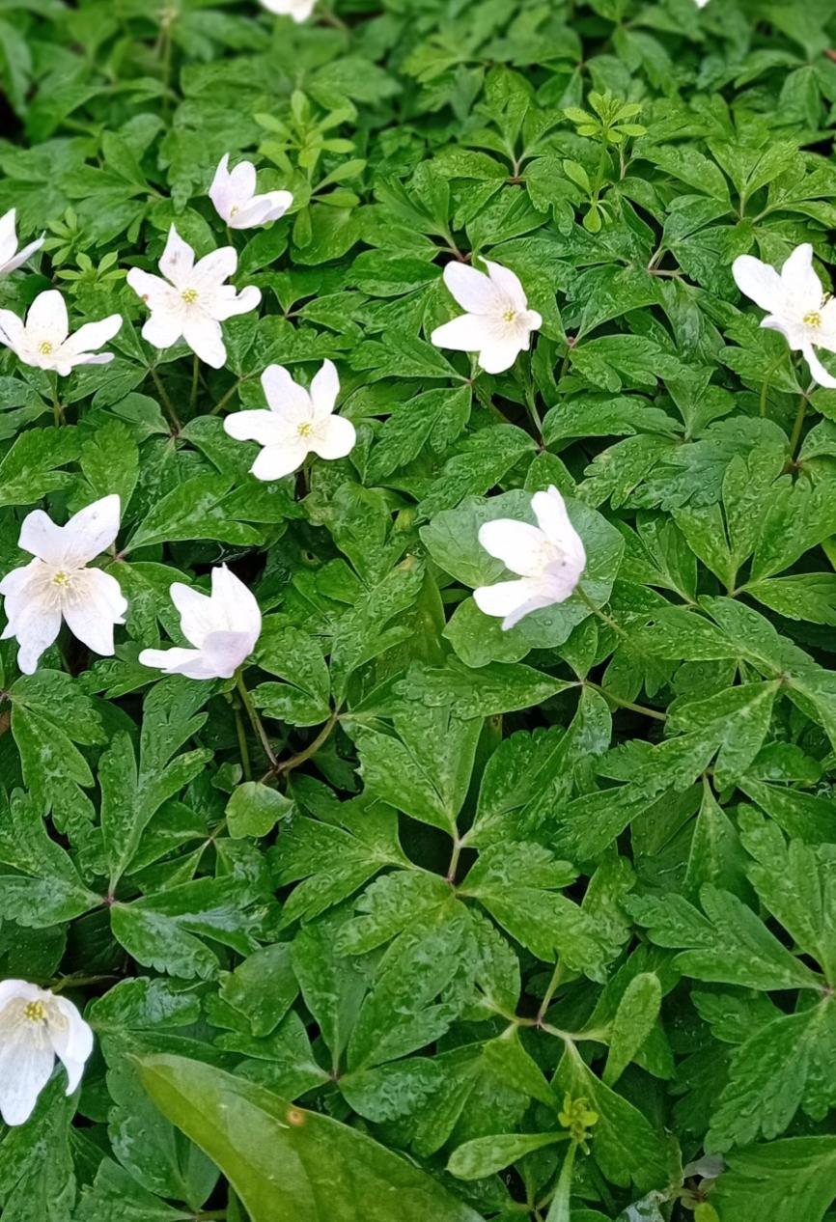

**Wood Anemone, *Anemone nemorosa*, at Sharphill Wood**

**Scope and Methodology**

The data in this report are based on 12 visits to the wood between 22nd February and 16th November 2024. Each visit lasted between 2 and 3 hours; the time of day varied. As described in previous reports, the methodology comprised walking south from the Peveril Drive entrance, down to the southern extremity of the wood, before returning north to the starting point, noting species which were present at any particular time. The precise transects taken on any particular visit varied, so that as far as possible all areas of the wood were covered. These included the northern, eastern, southern and western boundaries outside the wood, and the northern, eastern, southern, central and western footpaths inside the wood, as well as less frequent diagonal transects between footpaths.

As part of mitigation measures associated with the ongoing housing development to the north and east of the wood, a post and rail fence encircling the wood was constructed in the summer of 2018. Following this, a 30-metre wide ‘buffer’ zone in between the post and rail fence and the housing development was planted up by the developers in autumn 2018, on land (formerly agricultural) adjoining the north and east boundaries of the wood. This planting is described on the developer’s landscape plans as comprising ‘woodland edge core’ species, for example Pedunculate Oak and Field Maple, and ‘woodland edge’ species, for example Hawthorn and Dog-rose. In addition, since 2018, a range of other species have populated the buffer zone at ground level. However, the extent of this flora survey was limited to the wood itself and the immediate boundaries outside the wood; specifically, including the post and rail fence but not the buffer zone.

Identification was generally based on the observed flower, aided by other salient botanical features such as leaf, stem and fruit, where appropriate. Reference was also made to the expected flowering period and geographical distribution, as detailed in two reference documents: (1) ‘The Wild Flower Key’, Francis Rose, 2006, for wild flowers and trees, and; (2) ‘Collins Pocket Guide. Grasses, Sedges, Rushes and Ferns of Britain and Northern Europe’, R. Fitter, A. Fitter and A. Farrer, 1984, for grasses, sedges, rushes and ferns. The survey also drew on the list of species previously identified.

Based on the above methodology, a particular species was simply recorded as present on a spreadsheet; each record comprises the first confirmed sighting of the year for that particular species. The confirmed sighting would normally be triggered by the first observation in that year of a prominent botanical feature, typically the flower. Subsequent sightings of a particular species (for example, elsewhere in the wood on the same visit, or on a different visit at a different time) were not recorded; because of the size and complexity of the task, no attempt was made to categorise frequency (for example, by a ‘DAFOR’ scale), or to indicate distribution locally within the wood. The methodology used is not precise and on any particular visit some species may have been missed for a variety of reasons, such as missing the flowering period, not being in the right place at the right time, inexperience and/or simply a failure of observation. All visits were made by the author.

**Results**

The species recorded during the 2024 survey are listed in alphabetical order in Appendix 1 at the end of this report. The complete data from the 2024 and previous surveys by the author are located in worksheet ‘2017-24’ in the accompanying Excel Spreadsheet: ‘Flora Survey_2024_NC’. The Excel Spreadsheet includes all flora species which have been documented in Sharphill Wood from 2001 until the present time. A confirmed sighting of any particular species in 2024 is identified on the worksheet by an entry of ‘24’ in column I (entitled ‘2024’). The data from the previous seven years are shown alongside column I, in columns B, C, D, E, F, G and H, using a similar methodology. The results from surveys carried out by others, in 2015 and before, are located in a separate worksheet entitled ‘2001-15’. From 2021, a 3rd worksheet was included in the spreadsheet detailing the actual date on which the sighting was made. This additional information was included so that the data could be input onto Nature Counts, an online recording system for wildlife sightings which Nottinghamshire Wildlife Trust started using in 2021 and for which the actual sighting date is required information: (<https://record.nottinghamshirewildlife.org/#:~:text=About,Nature%20Recovery%20strategy%20in%20Nottinghamshire>).

This information is required once only for each species identified; accordingly, from 2021 onwards, the date of the first sighting of each species has been recorded on this 3rd worksheet, suffixed ‘NC’. For any ‘new’ species sighted for the first time in 2024, the 3rd worksheet, entitled ‘2024 NC’, contains the same ‘new’ 2024 species sightings as in worksheet ‘2017-2024’, but with the actual date of the sighting recorded. For completeness, any sightings which were first recorded prior to 2021, but not sighted subsequently until the current observation year (and therefore not previously uploaded to NC) are also routinely entered on this 3rd (‘NC’) worksheet; there were no such sightings in 2024.

The 2023/2024 winter season was mild and consistently wet, with only occasional periods of drier weather between October 2023 and March/April 2024. In the spring and early summer, temperatures were near normal, although cool winds were frequent. The weather remained mild and damp throughout the summer and early autumn. As in 2023, the summer was generally warm, not hot as in 2022, with some woodland plants continuing to flower though September and into October.

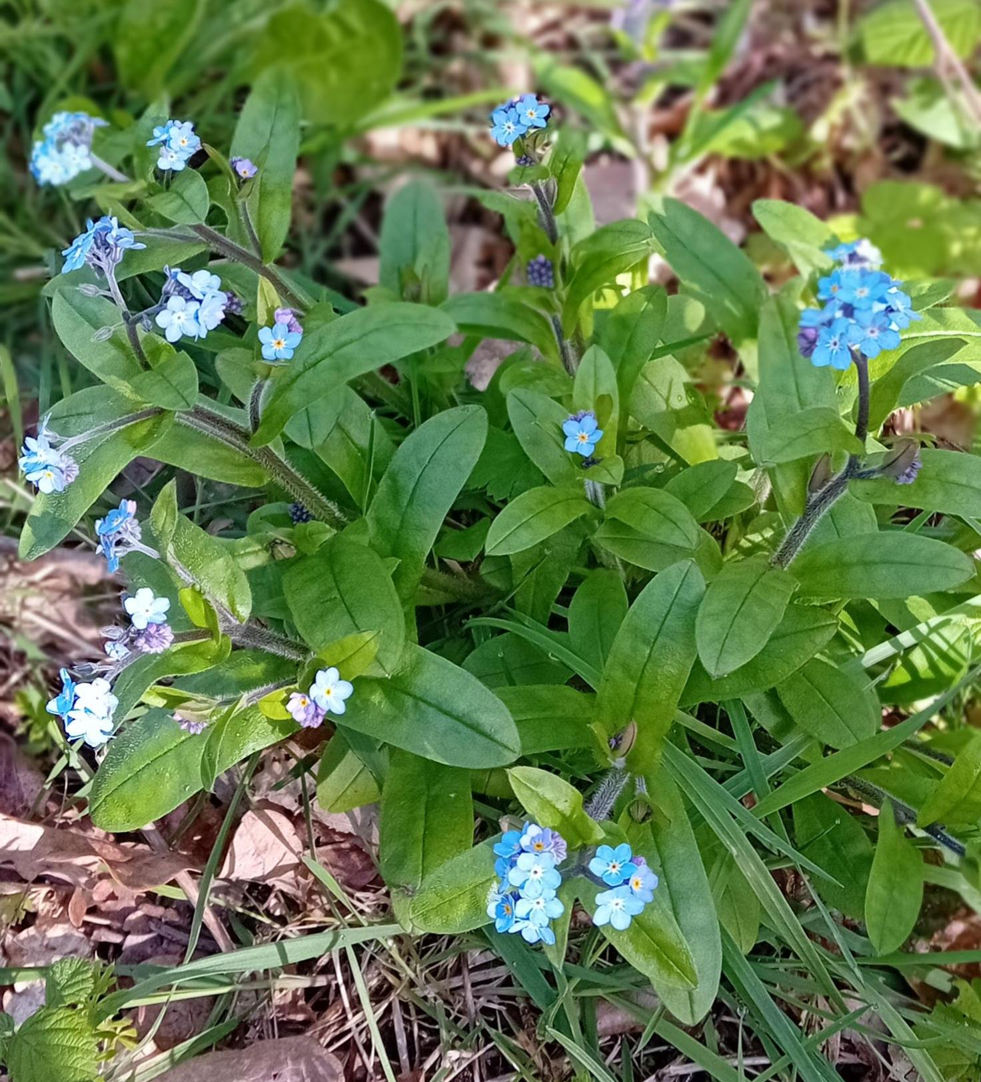

**Wood Forget-me-not*, Myosotis sylvatica,* at Sharphill Wood**

**Commentary and Conclusions**

The reader is referred to Appendix 1 below for details of the individual plants identified in 2024 (and to the accompanying Excel Spreadsheet: ‘Flora Survey_2024_NC’ for the complete data from the 2024 and previous surveys). In summary, 95 species of wildflower, 30 species of tree and 17 species of grass, sedge, rush and fern were identified in 2024 (a total of 142 species), including some not previously recorded. As in previous surveys, some species which have been recorded in earlier years were not identified in 2024 (these are shown by a blank entry in column I). It is likely that the reasons for this include the observational issues outlined above, species variability and the ongoing development (rather than any significant change in composition).

Richard Elliott, on behalf of Friends of Sharphill Wood.

**APPENDIX 1**

**SPECIES RECORDED DURING SHARPHILL WOOD FLORA SURVEY 2024**

**Wild Flower Species** **Recorded as Present, 2024**

Agrimony (Agrimonia eupatoria)

Anemone, Wood (Anenome nemorosa)

Avens, Wood (Geum urbanum)

Bindweed, Field (Convolvulus arvensis)

Bluebell,Spanish(Hyacinthoides hispanica)

Bluebell (Hyacinthoides non-scripta)

Bramble (Rubus fructicosus)

Bryony, Black (Tamus communis)

Bryony, White (Bryonia dioica)

Burdock, Lesser (Arctium minus)

Buttercup, Bulbous (Ranunculus bulbosus)

Buttercup, Creeping (Ranunculus repens)

Buttercup, Meadow (Ranunculus acris)

Campion, Bladder (Silene vulgaris)

Campion, Red (Silene dioica)

Celandine, Lesser (Ranunculus ficaria)

Charlock (Sinapis arvensis)

Cleavers (Galium aparine)

Clover, Red (Trifolium pratense)

Clover, White (Trifolium repens)

Cowslip (Primula veris)

Crane's-bill, Cut-leaved (Geranium dissectum)

Crane's-bill, Dove's-foot (Geranium molle)

Crane's-bill, Hedgerow (Geranium pyrenaicum)

Crane's-bill, Meadow (Geranium pratense)

Crane's-bill, Pencilled (Geranium versicolor)

Crane's-bill, Small-flowered (Geranium pusillum)

Cuckoo-pint (Arum maculatum)

Currant, Flowering (Ribes sanguineum)

Daisy (Bellis perennis)

Daisy, Oxeye (Leucanthemum vulgare)

Daffodil (Narcissus pseudonarcissus)

Dandelion (Taraxum agg)

Dead Nettle, Red (Lamium purpureum)

Dead Nettle, White (Lamium album)

Dock, Broad Leaved (Rumex obtusifolius)

Dock, Clustered (Rumex conglomeratus)

Dock, Curled (Rumex crispus)

Dock, Wood (Rumex sanguineus)

Dog-violet, Common (Viola riviniana)

Dog-violet, Early (Viola reichenbachiana)

Enchanters Nightshade (Circaea lutetiana)

Forget-me-not, Early (Myosotis ramosissima)

Forget-me-not, Field (Myosotis arvensis)

Forget-me-not, Wood (Myosotis sylvatica)

Ground-ivy (Glechoma hederacea)

Groundsel (Senecio vulgaris)

Hawkweed - Few Leaved (Hieracium agg)

Hedge-parsley, Upright (Torilis japonica)

Hemlock (Conium maculatum)

Herb-Robert (Geranium robertianum)

Hogweed (Heracleum sphondylium)

Honesty (Lunaria annua)

Honeysuckle (Lonicera periclymenum)

Ivy (Hedera helix)

Knapweed, Common (Centaurea nigra)

Knotgrass (Polygonum aviculare)

Lettuce, Prickly (Lactuca serriola)

Mayweed, Scented (Matricaria recutia)

Medick, spotted (Medicago arabica)

Mugwort (Artemisia vulgaris)

Mustard, Garlic (Alliaria petiolata)

Mustard, Hedge (Sisymbrium officinale)

Nettle, Common (Urtica dioica)

Orchid, Early-purple (Orchis mascula)

Oregon-grape (Mahonia aquifolium)

Oxtongue, Bristly (Picris echioides)

Parsley, Cow (Anthriscus sylvestris)

Pimpernel, Scarlet (Anagallis arvensis)

Pineappleweed (Matricaria discoidea)

Plantain, Greater (Plantago major)

Plantain, Ribwort (Plantago lanceolata)

Poppy, Common (Papaver rhoeas)

Ragwort, Common (Senecio jacobaea)

Scabious, Field (Knautia arvensis)

Selfheal (Prunella vulgaris)

Shepherd's-purse (Capsella bursa-pastoris)

Snowdrop (Galanthus nivalis)

Sow-thistle, Smooth (Sonchus oleraceus)

Sow-thistle, Perennial (Sonchus arvensis)

Sow-thistle, Prickly (Sonchus asper)

Speedwell, Common Field (Veronica persica)

Speedwell, Germander (Veronica chamaedrys)

Speedwell, Ivy-leaved (Veronica hederifolia)

Speedwell, Wood (Veronica montana)

St John's-wort, Perforate (Hypericum perforatum)

Thistle, Creeping (Cirsium arvense)

Thistle, Spear (Cirsium vulgare)

Trefoil, Hop (Trifolium campestre)

Vetch, Common (Vicia sativa)

Violet, Sweet (Viola odorata)

Willowherb, Great (Epilobium hirsutum)

Willowherb, Rosebay (Chamerion angustifolium)

Willowherb, Broad Leaved (Epilobium montanum)

Woundwort, Hedge (Stachys sylvatica)

**Grass, Sedge, Rush and Fern** **Species Recorded as Present, 2024**

Barley, Wall (Hordeum murinum)

Brome, Barren (Bromus sterilis)

Brome, False (Brachypodium sylvaticum)

Brome, Hairy (Bromus ramosus)

Brome, Meadow (Bromus commutatus)

Brome, Soft (Bromus hordeaceus)

Cocksfoot (Dactylis glomerata)

Couch Grass, Bearded (Elymus caninus)

Couch Grass, Common (Elytrigia repens)

Fern, Broad Buckler (Dryopteris dilatata)

Fern, Male (Dryopteris filix-mas)

Meadow-grass, Annual (Poa annua)

Meadow-grass, Rough (Poa trivialis)

Oat-grass, False (Arrhenatherum elatius)

Oat-grass, Yellow (Trisetum flavescens)

Rye-grass, Perennial (Lolium perenne)

Yorkshire Fog (Holcus lanatus)

**Trees Species Recorded as Present, 2024**

Ash (Fraxinus excelsior)

Beech (Fagus sylvatica)

Blackthorn (Prunus spinosa)

Cherry, Bird (Prunus padus)

Cherry, Wild (Prunus avium)

Chestnut, Sweet (Castanea sativa)

Crab Apple (Malus sylvestris)

Dog-rose (Rosa canina agg)

Dogwood (Cornus sanguinea)

Elder (Sambucus nigra)

Elm, Wych (Ulmus glabra)

Field-rose (Rosa arvensis)

Guelder-rose (Viburnum opulus)

Hawthorn (Crataegus monogyna)

Hazel (Corylus avellana)

Holly (Ilex aquifolium)

Lime (Tilia x europaea (T. x vulgaris))

Maple, Field (Acer campestre)

Maple, Norway (Acer platanoides)

Oak, Pedunculate (Quercus robur)

Oak, Red (Quercus rubra)

Oak, Sessile (Quercus petraea)

Plum, Cherry (Prunus cerasifera)

Pine, Scots (Pinus sylvestris)

Privet, Wild (Ligustrum vulgare)

Rowan (Sorbus aucuparia)

Spindle (Euonymus europaeus)

Sycamore (Acer pseudoplatanus)

Willow, Goat (Salix caprea)

Yew (Taxus baccata)