Friends of Sharphill Wood
2020 Annual Report
May 2020

Founded 22 January 2008: Twelfth Annual Report

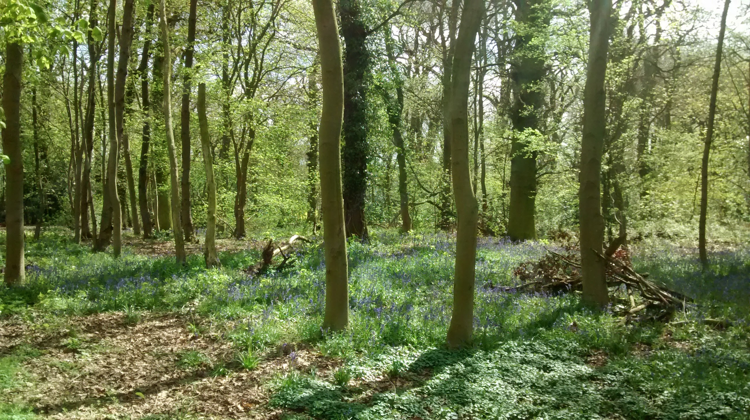
There were 8 ordinary meetings of the Friends of Sharphill Wood in the year to 12 May 2020. The 10 September 2019 meeting was inquorate, the 8 October meeting was cancelled because of the number of apologies and the 14 April and 12 May 2020 meetings were cancelled in response to the Covid-19 virus outbreak. The Annual General Meeting on 14 May 2019 elected Phil Miller (Chair), Chrissie Wells (Vice Chair), Chrissie Wells (Treasurer), Jo Miller (Publicity Officer) John Elwell (Work Party Coordinator), Richard Elliott (Deputy Work Party Coordinator) and Mike Rivett (Deputy Work Party Coordinator) and Bill Logan (Secretary). There were 63 Friends on the circulation list in May 2020, up from 38 in 2019 thanks to an increased Group profile (See Publicity below).

Management Developments

Our Management Plan covering the period 2018 – 2023, launched on 12 May 2018, was reviewed on 20 August 2019 with Paul Phillips of Rushcliffe Borough Council and Ben Driver of Nottinghamshire Wildlife Trust. Working from a newly drawn up monitoring form it was agreed nothing need be raised from what had not been fully achieved and it was decided to leave tasks 1.9 (Planting understorey) and 1.10 (Planting canopy) to Year 2 as the timescales for each task were flexible. Open questions remain on when s106 funding from the housing developers would be available and thinning the north of the wood. Details of what has been achieved in the year can be found under Work Parties below.

Unfortunately, due to personnel changes at both Bovis and the Council we have made no progress during the year with tackling the mitigating measures to protect the wood from the housing development. We continue to press for a meeting with both to tackle, in the short-term, completion and repair of the fence and buffer zone and access to storage.

During the summer we attended the Repton Road Street party and the Wild Woodland Gathering at Skylarks when we had a popular quiz with prizes donated by Collins & Co, which produced some interest in attending our work parties.

There were the usual incidents of antisocial behaviour, which we reported to Rushcliffe Borough Council. The remains of two parties were reported during the summer and a local school advised of evidence left by one of their pupils. The school said that the pupil and his parents had been spoken to. The lock and chain at the Peveril end gate had been removed and the mouth of the badger sett to the NW of the wood had been badly damaged. The latter was also reported to the Badger Trust and the Police.

On a brighter note we received 420 free trees from the Woodland Trust, which were planted along the eastern boundary as detailed under the Work Parties report. Rushcliffe Borough Council also gave 10 canopy trees which we have planted in the western edge of zone 3. From funds donated by local councillors we were able to buy 250 trees from Naturescape and were donated a further 100 free trees from TCV for the boundary. Unfortunately, the Covid-19 virus outbreak prevented the planting of 200 of these trees, but we have dug these in and hope we will still be able to plant these out in the autumn.

As usual, we had an informal social at The Test Match on 10 December.

Publicity

The role of publicity officer covers a variety of areas. From helping with the recruitment on new volunteers to the group. To the updating on the website, receiving incoming emails and passing them to the relevant officers. To looking after and updating the facebook page. Responding to incoming messages as well as admin duties like creating posters, laminating items for the noticeboards.
Notice of work parties are placed on facebook, Nextdoor, do-it.org, CJS and Nottshelpyourself, which have helped increase our profile and we are listed on the NWT and RNCSIG activities material.

I have been working to make the website an archive of the groups work. This will continue over the coming months with new areas being added to it. I am also pleased to confirm that the “contact us” page on the website is now working again making easier for our visitors to get in touch with us.

Nature Surveys
Nest box inspections were carried out again during spring 2019 and results, summarised here, were submitted to the British Trust for Ornithology Nest Record Scheme. With fine weather early on, things looked quite promising for Blue Tits and Great Tits. But although chicks were hatched in 8 boxes (4 of each species), clutch sizes were very small and a lot of chicks did not survive. Very few Great Tits fledged and only a modest number of Blue Tits. Apparently similar results were seen elsewhere in the region and may be linked to colder weather in early May and a general shortage of caterpillars. 24.5 volunteer-hours were spent on site carrying out these inspections. Spring 2020 inspections have been unable to start because of Covid-19, and it is unlikely they will be able to start in time to provide meaningful results.
A series of bird surveys conducted at roughly 2-week intervals from late March to early June led to the publication of a report "Spring Birds at Sharphill Wood 2019". It gives a broad picture of birds present at the site during the breeding season and very rough estimates of the number of pairs of most species. A similar report had been produced in 2018. This survey involved 21.5 volunteer-hours on site. Covid-19 restrictions are preventing such a detailed survey in 2020, although it is anticipated that a report will still be produced based on casual observations on site while engaging in allowed daily exercise. The 2020 report will necessarily be less quantitative than usual.

We conducted a further flora survey in the wood during 2019, to compliment earlier surveys. The 2019 weather was characterised by a relatively cool and dry spring, followed by a warm summer with plenty of rainfall, conditions which are generally favourable for the typical woodland flora. Following the construction of the post and rail fence encircling the wood in 2018, during 2019 many of the plants normally found in the herbaceous zone surrounding the wood have re-appeared. In summary, 82 species of wildflower, 26 species of tree and 11 species of grass, sedge, rush and fern were identified in 2019 (a total of 119 species), including 7 plants not previously recorded. As in previous surveys, some species which have been recorded in earlier years were not identified in 2019. However, the reasons for this are believed to be logistical and practical, rather than reflecting any significant change in composition. The flora survey involved 13 visits by Richard, clocking up 30 volunteer-hours. It is hoped that the Covid-19 restrictions will not significantly influence the execution of the 2020 survey, which is currently underway.

Work Parties
During the period May 2019 to April 2020 we held 8 scheduled Sunday work parties, but had to cancel the July one because of very heavy rain and the March and April 2020 ones because of Covid-19. However, we held extra work parties in early September and early January. In addition, John attended with an assistant on three occasions (in August, October and February) to carry out brush-cutting in preparation for planting. Also, again with assistance, John carried out annual nest box servicing in December and January. Participation had been rather low up until early autumn, but thanks to a good amount of publicity we enjoyed better attendance from late autumn onwards, including quite a number of new recruits. During these various sessions, and taking into account low risk work (such as site inspections) carried out by individuals on other occasions, we clocked up 371 volunteer-hours on site.

Much of the year's work was centred around planting the aforementioned donated and purchased trees, including woodland edge trees down the eastern boundary and canopy trees (oak and small-leaved lime), plus a few understorey trees, in a second trial planting area near the western path. This included some preparation work using the brush-cutter and hand tools. Also some attention was given to tending trees planted in previous years, including the first trial planting area for canopy trees near the southern end of the main path. The planting and associated work took up much of the autumn and winter, but we also found time to thin some invasive tree species, mainly Norway maple but also some sycamore. For the late January work party we were able to borrow two tree poppers from Notts Wildlife Trust to allow us to uproot saplings that didn't exceed about 2cm diameter at their base. For the June work party Notts Wildlife Trust let us borrow their scythes again to trim back encroaching vegetation on paths. We did a little more work on path edging at the northern end of the site, litter picking within the context of the Clean and Green campaign (see below), and distribution of stones to muddy sections of paths.

Community Participation
Sadly the planned dawn chorus walk in late April 2020 had to be cancelled because of Covid-19.

Clean and Green Campaign

The £800.00 received through Neighbourly from TK Maxx and Homesense was most welcome although we thought carefully about how we could best use these funds. The funding came from the sale of plastic bags in their stores, as opposed to them giving out free plastic bags. The Clean and Green Project also made a good fit with the 5 year Management Plan objectives 2.3, 2.4, 3.1 and 3.2.

We decided to ensure that work parties became more litter focused and to record what was collected for the funders. The results were very interesting. We also publicised the project to scout and guide groups, forest schools, U3A and a range of other groups that we thought may be interested. As incentive we offered to refund expenses or provide kit for the clean ups. Streetwise initially offered to support us, but in the event were not able to. Our main heroes were the children of St. Edmund Campion Catholic Voluntary Academy, who are already familiar with Sharphill Wood. They spent a morning (64 children and 8 teachers) on a litter pick, and we provided their high viz vests, litter pickers, safety gloves and recycled plastic bags. They are likely to carry out further litter picks when circumstances allow, so the kit will be put to good use.

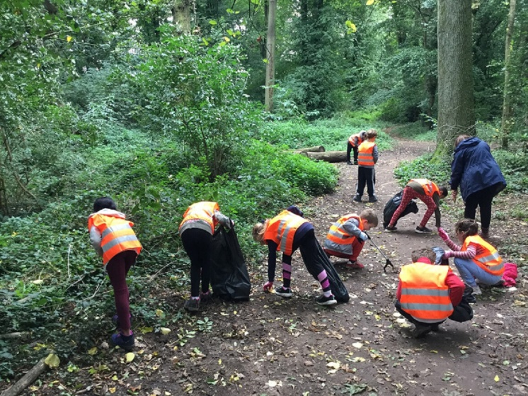
For our own litter picking we retained litter pickers, gents, ladies and children’s gloves, grubbers for the important task of removing broken glass, ring pulls and bottle tops which tend to be left behind, as people focus on larger items of litter. The School generated great publicity for themselves and the Wood with Bdaily News, West Bridgford Wire, Nottingham Local News, East Midlands Connected. They collected 32 small bags of rubbish!

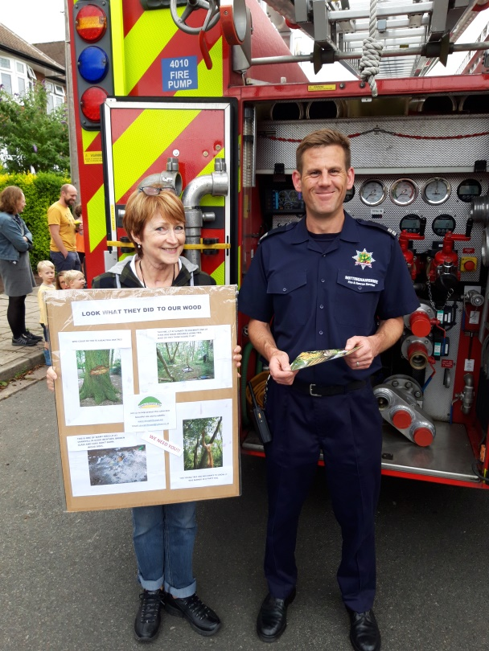

As the educational part of the project, we attended the Repton Road Street Party in July, raising awareness of the mess and damage caused in the past to the Wood through parties with fires. The Notts Fire and Rescue Service also attended this.

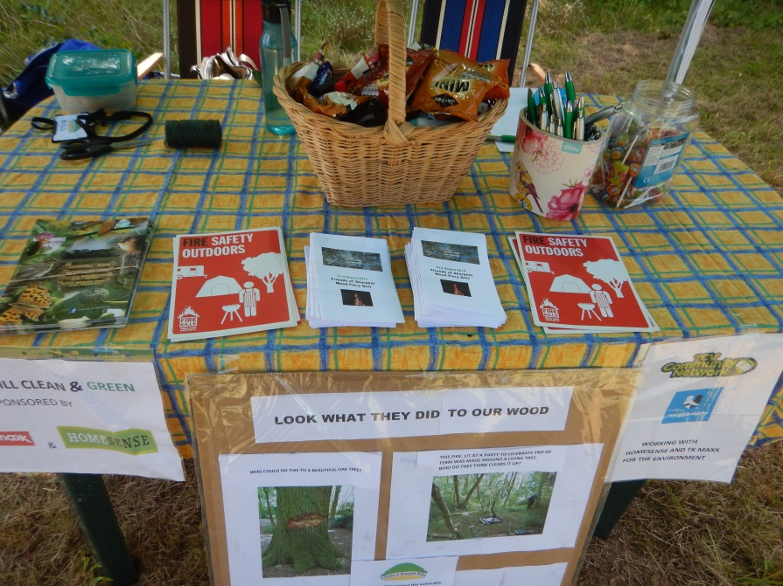
In August we attended the Notts Wildlife Trust event at Skylarks for educational purposes. At both events we asked the children to complete a quiz about the effects of fires and litter and gave goodies to all, which was successful in attracting families to the stall.

T

he final statistics were as follows:-
· 13 events held including regular work party activity
· 37 bags of rubbish collected
· On 2 occasions 40% of the rubbish was recycled
· The whole wood and boundaries were covered (normally we do not clear rubbish outside the wood boundary)
· 219 people participated in litter picking
· 211 people were educated in litter and recycling (some of those participated in the litter picking) Final Spend was £799.12
Altogether this was a well worthwhile project which raised the profile of the wood. Volunteer numbers did pick up over 2019, although this may have been coincidental!

Finance
Friends of Sharphill Wood Financial Report 1st April 2019 to 31st March 2020

The main feature of 2019 was the unsolicited receipt of £800 mentioned above. These grant funds were raised through sale of plastic bags, to be used for environmental projects. We designed and delivered such a project to be eligible for the funds, with great success. Some of our regular cleaning up duties fell under the criteria, however we generated more activity and in particular with the involvement of St. Edmund Campion Catholic Voluntary Academy, who carried out a big litter pick with 64 children and 8 adults focusing on small stuff like bottle tops and broken glass, but managing to collect 16 full bags of rubbish!
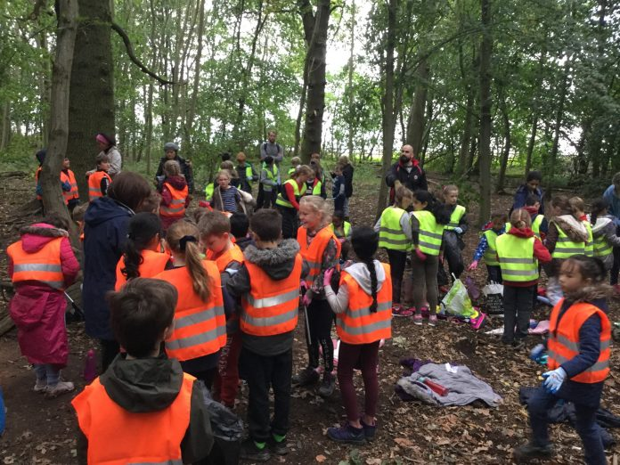
T

hey also achieved very good publicity for Sharphill Wood, as did all the other activity. The funding enabled us to provide safety kit for the school and also for ourselves in the shape of litter pickers, safety gloves and recycled plastic bags. The school has said that it may be able to carry out further litter picks during 2020 and beyond.

The other major items of expenditure related to the reported whip planting activity, to fund purchase of whips, canes, guards and tree ties.

However it must be pointed out that free trees have always been provided by Woodland Trust as well, so the massive autumn/winter planting to protect the eastern boundary with a buffer zone was well provided. The bulk of funds required came from grants from Councillor Wheeler (not shown in this year’s accounts).

We continued to use Su and Frank Collins’ home for our meetings, for which we have been really grateful. However since it has become logistically difficult for them to continue to provide a monthly venue, most meetings in future will now be held at 1 Ralf Close West Bridgford. Collins also provided funds for us to service our brush-cutter.

Although disposable funds ended up quite low at the year end, we are not particularly concerned. Zurich Insurance have waived 3 months premium to help groups cope with the pandemic situation, and we are aware that when we have needed funds in the past all the local councillors have been flexible and helpful.

Altogether a satisfactory year!

Acknowledgements

Thanks are again due to Nottinghamshire Wildlife Trust, especially Ben Driver, Paul Phillips of Rushcliffe Borough Council and Gordon Dyne of the South Notts Group for their continued advice and support. We are grateful to Mr. and Mrs. Collins for allowing us to use their home for our meetings until recently. Also, thanks to the many volunteers who helped at our work parties, litter picks and surveys, and to Ian Mumford, who has moved out of the area, for his long time attendance at work parties and meetings. Thanks also to Notts Wildlife Trust for kindly letting us use their scythes at the June work party and their tree poppers at the January work party.

Phil Miller (Chair), Chrissie Wells (Vice Chair & Treasurer), Jo Miller (Publicity Officer), John Elwell (Work Party Coordinator), Richard Elliott & Mike Rivett (Deputy Work Party Coordinators), and Bill Logan (Secretary).

