Friends of Sharphill Wood
2019 Annual Report
May 2019

Founded 22 January 2008: Eleventh Annual Report
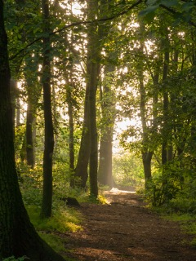
There were 9 ordinary meetings of the Friends of Sharphill Wood in the year to 14 May 2019 of which two were inquorate. The Annual General Meeting on 8 May 2018 elected Phil Miller (Chair), Mike Rivett (Vice Chair), Chrissie Wells (Treasurer), Jo Miller (Publicity Officer) John Elwell (Work Party Coordinator) Richard Elliott (Deputy Work Party Coordinator) and Rachel Dales (Deputy Work Party Coordinator. Resigned 18/10/18) and Bill Logan (Secretary). There were 38 Friends on the circulation list in May 2019, down from 106 in 2018 due to the requirement to agree retention of contact details (See below).

Management developments

Our Management Plan covering the period 2018 – 2023 was launched on 12 May and we have agreed to review it annually.

As with 2018 much of our time has had to be devoted to ensuring adequate measures be put in place to mitigate damage from the housing development next to the wood. A boundary fence has been erected around the wood effectively extending it by 7m on the eastern edge. We are following up, with the help of Councillor Simon Robinson, the damage already done to the fence and the lack of gates. We have not been able to have the fence extended from the Wheatcroft end to the A52, but a gate to replace the fence blocking our vehicular entrance has been promised. The buffer zone has been planted within a post and wire fence from the Peveril to Wheatcroft entrances. The developers have provided two information panels for the Peveril and Wheatcroft entrances and are issuing a welcome pack to new residents with information on our work for the wood

We have reviewed and amended our existing Safeguarding Young People and Vulnerable Adults policy and created a new policy for Compliments, Suggestions and Complaints and one for Privacy.

An inordinate amount of time has been spent ensuring our compliance with the General Data Protection Regulation. This has resulted in the drop in registered Friends and the above Privacy policy. We have also reviewed our retention and distribution of documents, which are now done via Dropbox, GoogleDocs and Sendinblue.

Incidents of antisocial behaviour continue to be reported to Rushcliffe Borough Council. One particulary bad incident, where a young tree was felled, was reported to West Bridgford School as there was evidence that it was committed by one or more of their pupils. The school responded to say appropriate action had been taken.

As usual, we had an informal social at The Test Match on 11 December

10th Anniversary Celebration

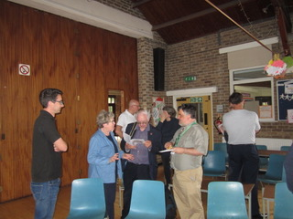
Our tenth year of existence was marked by a special event on 12 May attended by 25 guests including the Deputy Mayor of Rushcliffe Borough Council,
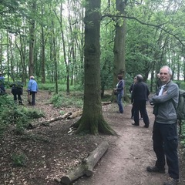
Councillor Maureen Stockwood and Councillors Debbie Mason, Francis Purdue-Horan and Karrar Khan. Other specially invited guests attending were Valerie Holt of Nottinghamshire Wildlife Trust, PC Dave Blundell and Dr Chris Terrell-Nield. Ben Driver from Nottinghamshire Wildlife Trust outlined what the Trust does as a whole for the county and what the Friends have done for Sharphill in particular, while Paul Phillips, Environmental Sustainability Officer for Rushcliffe Borough Council, launched our revised Management Plan. The full report can be found here.

The event was followed by a visit to the wood by several of the attendees.

Tree infections

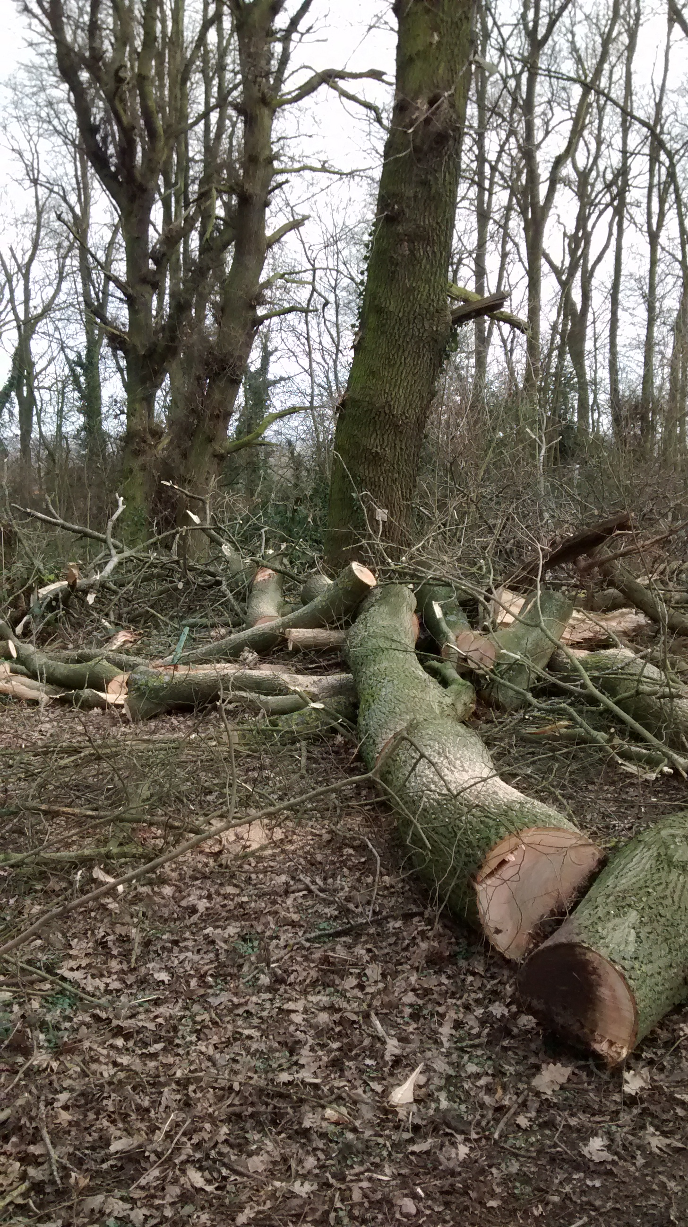
The saddest occurrence during the year was the discovery of yet more trees infected by disease. In summary, a number of Ash were felled, largely due to Inonotus hispidus which fairly quickly causes affected stems and branches to become brittle. One Beech with ganoderma was found; this is fairly slow acting, but as there were fungal brackets on both sides of the trunk it seemed fairly well established. A couple of trees with Ustulina were found, which keeps changing its name and should now be known as Kretzschmaria deusta. This is a dangerous fungal decay partly because it is easy to overlook and because it again causes trunks to become brittle and fracture.
We have already started planting replacement trees, donated by Rushcliffe Borough Council, and will be discussing with them further planting to regenerate the wood.

Publicity

Over the last 12 months the new website has been up and running. An archive of work party write-ups between 2010 and 2016 have been added. The website and Facebook page were regularly updated to make sure they remained dynamic and effective.
Our Facebook page now has 144 people who like it and regularly view it also 149 people who follow the Friends of Sharphill Wood page. These people are not just from Nottingham but are from all over the world with our articles reaching between 10 and 131 people.
Articles for the West Bridgford Local News, outlining what we do as a Group, have been published. Maintaining the website involved keeping people informed about what we are doing, requesting their input and encouraging new volunteers. The group email box was also monitored by Jo Miller and incoming emails forwarded to the relevant officers for action. We have regularly updated and replaced posters in the notice boards in the wood showing, for example, dates of work parties and walks, these are now also on our website.
2019/2020 for this role will continue to be a busy year as we are always looking at ways to encourage new volunteers through our website, facebook page and articles.
The website still has lots of scope for improvements and changes will be taking place over the next 12 months.

Nature surveys

We conducted a further flora survey in the wood during 2018, advised by Gordon Dyne and building on the 2017 and earlier surveys. The 2018 weather was characterised by an extended period of cool and wet weather in the spring, followed by a hot and dry summer period. The lack of moisture in late summer undoubtedly influenced the flowering of many of the woodland plants, specifically, they simply did not flower. At the same time, construction during the summer of a post and rail fence encircling the wood, as part of mitigation measures associated with the ongoing housing development to the north and east of the wood, significantly influenced the plants normally found in the herbaceous zone surrounding the wood. Notwithstanding, the survey identified 79 species of wildflower, 26 species of tree and 10 species of grass, sedge, rush and fern (a total of 115 species), including 13 plants not previously recorded. As in 2017, some wildflower, and grass, sedge, rush and fern, species which have been recorded in previous years were not identified in 2018. However, there are a number of practical reasons why certain species may or may not be recorded in any given year (in particular, see above), and there is no evidence at present to suggest these changes reflect any significant change in composition. This survey involved 16 visits by Richard Elliott, clocking up 36 volunteer-hours. A 2019 survey is currently underway.
Nest box inspections were carried out again during spring 2018 and results, summarised here, were submitted to the British Trust for Ornithology nest record scheme. With fine weather in May, this turned out to be one of our best years since nest inspections began in 2013 (2014 was also very good). There were 4 successful great tit nests producing 23 fledglings, and 4 blue tit nests producing 24 fledglings. This work involved 6 visits and 17.25 volunteer-hours. Spring 2019 inspections have already started.
In the past, various informal bird surveys had been carried out. However, in spring 2018 a more elaborate survey was conducted, involving 5 early morning visits between mid-April and mid-June and resulting in a published report "Spring Birds at Sharphill Wood 2018". It gives a broad picture of birds present at the site during the breeding season and very rough estimates of the number of pairs of most species. This survey clocked up 15 volunteer-hours. A similar survey has been started in spring 2019.

In addition, two further surveys were carried out by others. A Bryophyte survey was completed at Sharphill, which was led by a British Bryological Society recorder. The full survey can be found here. Tim Williams, warden of Wilford Farm Cutting, carried out an invertebrate survey, which can be found here. Our thanks go to both for adding to the data of wildlife in the wood.

Work Parties
During the period May 2018 to April 2019 we held 10 scheduled Sunday work parties, but had to cancel the May one because very few volunteers were available that Bank Holiday Sunday. We did, however hold additional work parties in late August and early February, plus an additional small work party in November to service the nest boxes. Over the 13 work parties we clocked up 281 volunteer-hours (about 20 volunteer-hours per work party). Participation has fallen again slightly from the previous year, and the August, December and late February work parties were particularly lean. In addition, approximately 65 volunteer-hours were contributed by individuals carrying out practical tasks between work parties. We have benefitted at most work parties from young people doing Duke of Edinburgh awards.

At our June work party, once again we were fortunate in having the use of three scythes from Notts Wildlife Trust, kindly brought along and demonstrated by Nick Mills from Skylarks. As in the previous year, this proved to be an efficient, quiet and eco-friendly way of dealing with weeds along the sides of the main and west paths. At the July work party we checked recently planted whips and managed to bring up some water in jerry cans to help keep them going. The August work party was called primarily to remove fallen branches from the main path.

Over the autumn and winter months, a major project was clearing and planting a "trial planting area" towards the southern end of the main path in zone 3. The area benefitted from a considerable gap in the canopy, and we planted 9 canopy trees (small-leaved lime and oak) donated by Rushcliffe Borough Council, interspersed with some understorey trees. One of the Forest Schools kindly carried out much of the clearing. We also planted 170 hedging whips in the gap between the newly installed fence from the north-eastern corner southwards over a distance of about 120m, in order to strengthen the boundary. We plan to extend this planting further south next winter. In addition there was further felling of sycamore and Norway maple, using the arisings for dead hedging and path edging.

As usual there have been other ongoing jobs such dealing with the results of anti-social behaviour (e.g., litter), attending to whips, and removing fallen branches.

Two nest boxes have been installed again, after retrieval from fallen or condemned trees, and two more have been retrieved recently, awaiting re-installation in the autumn.

Community participation
Chrissie Wells continued to attend the West Bridgford Local Area Forum where she raised our concerns over anti-social behavior, the new housing development and other issues.

Richard Elliott and John Elwell led the publicised walk on 28 April. We had only two other participants. We walked the central and western paths and the south-eastern perimeter path, examining the various flowers that were out, some of the trees, and whatever birds happened to be around (including Nuthatch, Common Whitethroat and Linnet). During the walk 105 Early-purple Orchids were counted - 87 in the usual location, and a further 18 slightly SE and mostly under privet cover. It would seem that the two species co-exist successfully, therefore.

Finance

Friends of Sharphill Wood Financial Report 1st April 2018 to 31st March 2019
The Friends’ modest needs continue to be well supported by funders. This year benefactors were Councillor Karrar Khan, Councillor Gordon Wheeler, Councillor Jonathan Wheeler and Councillor Simon Robinson. Notcutts donated a raffle prize for the 10th Anniversary event – a lantern.

Our main expenditure was in carrying out part of our 5 Year Management Plan

1.9  Planting – under-storey | Consider supplementary planting of understory beneath any gaps in the high canopy with the following species:  Blackthorn Prunus spinose, Buckthorn (purging) Rhamnus cathartica, Crab apple Malus sylvestris, Dogwood (common) Cornus sanguinea, Field maple Acer campestre  Hawthorn Crataegus monogyna, Hazel Corylus avellana, Holly Ilex aquifolium  Wild privet Ligustrum vulgare, Rosa (dog) Rosa canina, Wild cherry Prunus avium  Wych elm Ulmus glabra  To aid establishment, the FoSW could trial planting groups of trees within stock proof fencing to aid establishment (say 4x8m). This has resulted in good establishment within sites in the west of the county.

1.10 Planting – high canopy | Under any significant gaps in the canopy, plant the following trees, with the aim of them eventually forming part of the main canopy:  - Pedunculate oak Quercus robur  - Small-leaved lime Tilia cordata or common lime Tilia x europaea  Trees will need to be protected by guards and mulch mats during the establishment phase.

We purchased 44 whips of varying species to comply with the above, plus the considerable expense of supporting canes and guards. We also purchased jerry cans to transport a limited supply of water to aid in establishment of the new whips. This timely work was carried out in February in an area where quite a few mature trees have recently fallen or had to be felled because of disease. Further whips will be planted this Autumn to reinforce boundaries, which is very necessary because of the additional pressures on the Wood which will arise because of the new housing developments.

Of course we continue to be grateful to Mr. and Mrs. Collins for allowing us to use their home monthly for our meetings and also for donating giveaways for the St. Paul’s summer fair. They also
allowed us to shop for refreshments for the Anniversary event at St. Paul’s at their Cash & Carry.

Acknowledgements

The Group would once again like to thank Nottinghamshire Wildlife Trust, especially Ben Driver, Paul Phillips of Rushcliffe Borough Council and Gordon Dyne of the South Notts Group for their continued advice and support. Also, thanks to the many volunteers who helped at our work parties and surveys, and to Rachel Dales for her work on the committee.

Phil Miller (Chair), Mike Rivett (Vice Chair), Chrissie Wells (Treasurer), Jo Miller (Publicity Officer), John Elwell (Work Party Coordinator), Richard Elliott (Deputy Work Party Coordinator), and Bill Logan (Secretary).

