Sharphill Wood

Management Plan

2018 – 2023

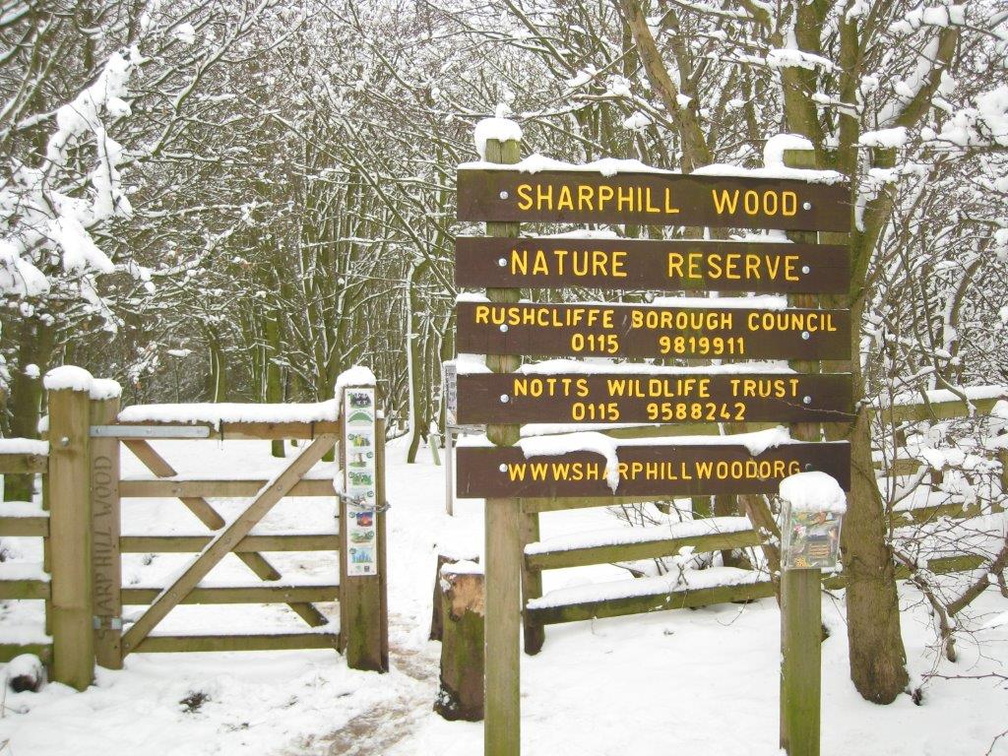

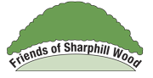****

This management plan was produced by Nottinghamshire Wildlife Trust in partnership with Rushcliffe Borough Council and Friends of Sharphill Wood.

February 2018

For internal use only

**CONTENTS**

INTRODUCTION 5

PART 1: ROLES AND RESPONSIBILITIES 6

**1.1 Rushcliffe Borough Council** 6

**1.2 Natural England** 6

**1.3 Environmental organisations** 6

**1.4 Nottinghamshire Wildlife Trust** 6

**1.5 Friends of Sharphill Wood** 6

**1.6 Local businesses and developers** 7

PART 2: DESCRIPTION 8

**2.1 Location** 8

**2.2 Map coverage** 8

**2.3 Owner** 8

**2.4 Size** 8

**2.5 Soil and geology** 8

**2.6 Aspect, topography and altitude** 9

**2.7 Access** 9

**2.8 Surrounding land use** 10

**2.9 Site description** 11

**2.10 Management zone descriptions** 11

Zone 1 11

Zone 2 12

Zone 3 12

Zone 4 12

Zone 5 12

**2.11 Statutory Designations** 14

**2.12 Non-statutory Designations** 14

PART 3: EVALUATION & OBJECTIVES 15

**3.1 Evaluation of site features (Ratcliffe’s criteria)** 15

**3.1.1 Size** 15

**3.1.2 Diversity** 15

**3.1.3 Naturalness** 15

**3.1.4 Rarity** 15

**3.1.5** **Fragility** 16

**3.1.6 Typicalness** 16

**3.1.7 Recorded history** 16

**3.1.8 Position in an ecological/geographical unit** 16

**3.1.9 Potential value** 17

**3.1.10 Intrinsic appeal** 17

**3.2 Objectives** 18

**3.3 Factors influencing management** 18

PART 4: MANAGEMENT STRATEGY 21

**4.1 Management tasks** 22

**4.2 5-year plan** 27

**4.3 Vision / targets** 28

**4.3.1 Objective 1 Maintain and enhance the habitat types and species present** 28

**4.3.2 Objective 2 Combine habitat enhancement and management with education, recreation and access provision** 30

**4.3.3 Objective 3 Encourage public understanding and awareness of issues relating to the site, including the archaeological and historical elements on the site** 31

**4.3.4 Objective 4 Monitor effects of management and visitor use on the wildlife on the site** 31

**4.3.5 Objective 5. Promote a viable Friends of Sharphill Wood group** 32

PART 5 REFERENCES 33

# INTRODUCTION

This management plan was produced by Nottinghamshire Wildlife Trust in partnership with Rushcliffe Borough Council and Friends of Sharphill Wood.

Sharphill Wood was declared as a Local Nature Reserve (LNR) in 2010. It is a wildlife reserve located south west of Edwalton and south of West Bridgford in Nottingham. In line with the aims and purposes of LNRs, Sharphill Wood provides people with ample opportunity for exercise and recreation, as well as to learn about nature and geology. The statutory LNR status that applies to the site will continue to help protect the wildlife and other interests of the site and increase local people's awareness and appreciation of it.

The previous management plan covered the period 2013 – 18. This management plan aims to achieve the following:

* maintain and enhance the habitat types and species present;
* combine habitat enhancement and management with education, recreation and access provision;
* encourage public understanding and awareness of issues relating to the site, including the archaeological and historical elements on the site;
* monitor the effects of management on wildlife;
* promote a viable Friends of Sharphill Wood group.

Local volunteering and the support of the local community through the active Friends of Sharphill Wood group is a valuable resource in terms of caring for and securing the future management of the site.

As Rushcliffe Borough Council’s and other partners’ vision for improving the site is continually being developed, the management plan will be reviewed every 5 years and adjusted accordingly.

# PART 1: ROLES AND RESPONSIBILITIES

## **1.1 Rushcliffe Borough Council**

Sharphill Wood LNR is owned by Rushcliffe Borough Council (RBC) and the council works in partnership with the Friends group, Nottinghamshire Wildlife Trust and other local environmental groups to manage this site. Rushcliffe Borough Council is keen to support partners who can undertake site work (either directly or through developing funded projects) to enhance wildlife habitats, as laid out in the management plan. As landowner, Rushcliffe Borough Council has a duty of reasonable care to ensure people’s safety and all events and work on this site should comply with their procedures.

For more information visit [www.rushcliffe.gov.uk/natureconservation](http://www.rushcliffe.gov.uk/natureconservation)

## **1.2 Natural England**

Natural England is an executive non-departmental public body, sponsored by the Department for Environment, Food & Rural Affairs. It is the Government’s adviser for the natural environment in England, helping to protect England’s nature and landscapes for people to enjoy and for the services they provide. Natural England provides advice on the declaration of LNRs in England and maintains a database of these sites.

<https://www.gov.uk/government/organisations/natural-england>

<http://www.lnr.naturalengland.org.uk/Special/lnr/lnr_search.asp>

## **1.3 Environmental organisations**

Environmental organisations are taking a lead role in Rushcliffe to improve wildlife habitats. For example, Rushcliffe’s Nature Conservation Strategy Implementation Group, consisting of a number of environmental organisations and representatives from groups with an interest in Rushcliffe’s natural environment, work together in partnership with the Local Authority to implement Rushcliffe’s Nature Conservation Strategy.

The Nottinghamshire Biodiversity Action Group has the responsibility for overseeing and monitoring the Nottinghamshire target habitats and species.

The Nottinghamshire Biological and Geological Record Centre (NBGRC) also has interest in LNRs in the context of their function to map Local Wildlife Sites, update county Phase 1 Habitat survey and maintain protected species records.

Other groups that could provide advice/ assistance have included BTCV and TCV (now Practical Conservation Volunteers CIC), scout / guides, groups etc. as well as local schools and universities.

## **1.4 Nottinghamshire Wildlife Trust**

Nottinghamshire Wildlife Trust (NWT) cares for over 67 Nature Reserves across the county, engages with the local community through events, education and volunteering opportunities and provides specialist ecological advice and support to partners and its members. <http://www.nottinghamshirewildlife.org>.

## **1.5 Friends of Sharphill Wood**

The Friends of Sharphill Wood <http://www.sharphillwood.org/> was formed on 28 January 2008 to enhance the LNR for the benefit of the local community and for flora and fauna. The Friends act as a partner in the management of the LNR, to help conserve and protect the LNR, to provide a vehicle for local people to voice their ideas and concerns, and allow them to raise funds for facilities or events they would like to see on site that existing budgets cannot accommodate. Some of the ways they achieve this are:

* promoting and carrying out species and habitat monitoring;
* raising awareness and public support for the LNR, including highlighting what site improvements are most important for local people;
* holding events and carrying out practical management tasks on site;
* raising funding for site specific projects.

More information on the Friends group can be found here: <http://www.sharphillwood.org/>

## **1.6 Local businesses and developers**

Local businesses and developers are invited to contribute to the delivery of this management plan. This could include supporting the Friends group on volunteering days, providing financial support for interpretation or other infrastructure projects, or providing technical or other assistance in enhancing the site for nature conservation.

# PART 2: DESCRIPTION

## **2.1 Location**

Sharphill Wood is located to the south of West Bridgford, within a triangle of land enclosed by the A60, A606 (Melton Road) and the A52, which lies to the south.

The site lies in the Borough of Rushcliffe, County of Nottinghamshire (Vice County 56).

The centre of the site is located at grid reference SK 586 349.

**Figure 1 Location map**

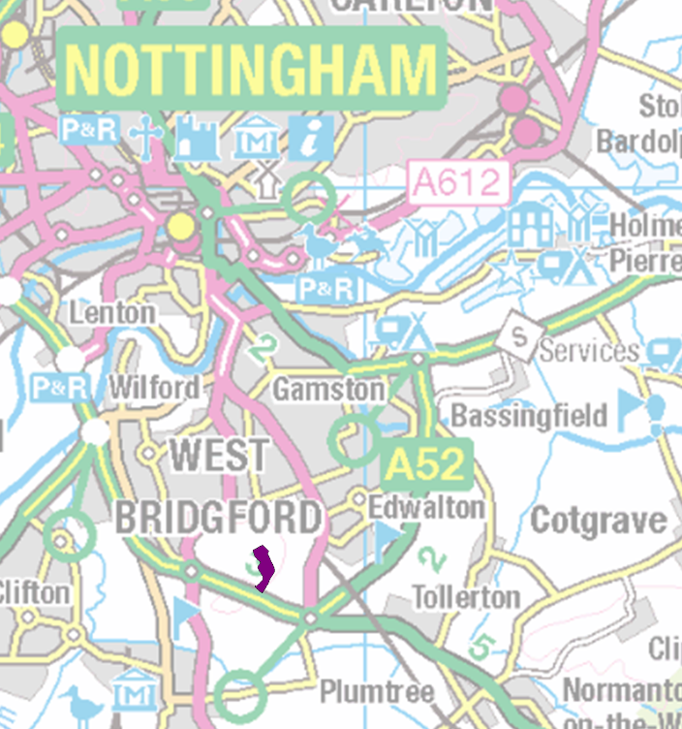

Sharphill Wood



Contains OS data © Crown copyright and database rights (2016)

## **2.2 Map coverage**

Ordnance Survey Landranger no. 129 (1:50 000 scale) & Ordnance Survey Explorer no. 260 (1:25 000 scale).

## **2.3 Owner**

Sharphill Wood is in the ownership of Rushcliffe Borough Council.

## **2.4 Size**

The wood is 9.72 ha (24.01 acres) in size.

## **2.5 Soil and geology**

Soil –The site comprises a small portion of sand and gravel to the North Westerly corner of the wood, whilst the remainder is heavy red clay (Land Use Classification sw/2 - clay surface or sub-soil texture; wetness owing to slow internal drainage (degree of limitation 2 at the most North Westerly corner and 3 for the remainder of the woodland)). The pH is variable over the site, registering between 5.6 and 7.0.

Geology - Mercia mudstone (Keuper Marl); a red and green marl with gypsum and occasional sandstones skerries (Geological Survey of Solid and Drift sheet 142) laid down in the Triassic Period.

## **2.6 Aspect, topography and altitude**

The wood has a southerly facing aspect at an altitude of 80m above sea level to its northern most boundary and 60m above sea level at its southern boundary.

The area lies within Natural England’s Natural Area, ‘Trent Valley and Rises’.

## **2.7 Access**

Formal access to the wood is from three points; one at the North West corner and two towards the southern end. There are also a number of designated public footpaths (rights of way), which more or less provide a circular loop around the wood. These are shown on Figure 2.

**Figure 2 Map showing public rights of way and formal access points**

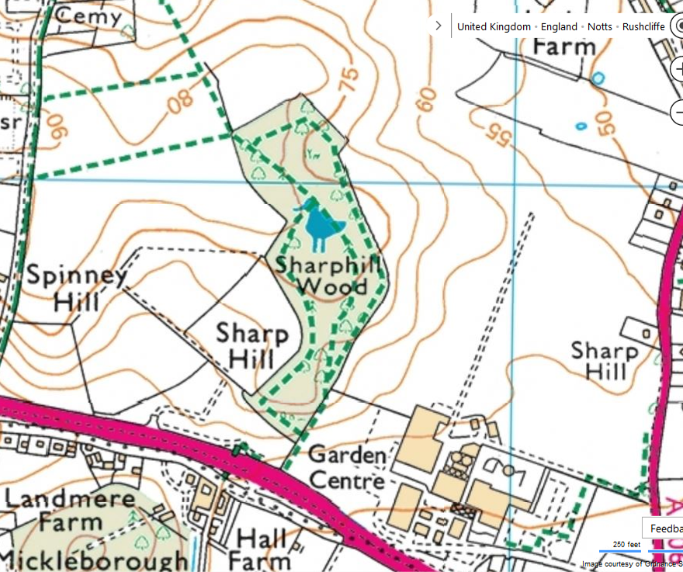

Access point

*Image courtesy of Ordnance Survey (2016)*

In addition, there are a number of informal paths. Much work has been carried out in recent years to limit access to the wood to the official public rights of way access points, to reduce the levels of visitor disturbance within the wood. Further access may be developed as required. However, due to the absence of laid paths and open gates, it is not possible for mobility impaired people to easily access the wood.

## **2.8 Surrounding land use**

Until 2016, the wood was surrounded by arable agricultural land, as shown in Figure 2. The wood itself and fields to the East and West are sloping with a southerly facing aspect, whilst the fields to the North have a northerly facing slope falling from 80m to 60m in altitude. The fields are bounded to the South by the A52 ring road, to the SE by a garden centre and light industrial unit and to the West by Southern (Wilford Hill) Cemetery leading to Wilford Hill Wood, a mixed woodland site currently managed by Nottinghamshire Wildlife Trust.

Land off Melton Road, which lies to the east of the wood, has been identified as a ‘strategic allocation’ in the adopted Rushcliffe Local Plan Part 1 (Core Strategy). Several planning applications are currently being considered/ have been approved for housing development on this land and part of the site is being built at the time of writing.

The Framework Plan, which the developers must have strong regard to when designing and building the site, is shown at Figure 3.

**Figure 3 Sharphill Wood Development Framework Plan (source Sharphill Wood adopted Supplementary Planning Document)**



Sharphill Wood

It is proposed that a ‘community park’ and Green Infrastructure will be created next to the wood, along with some linear spaces that will hopefully act as ‘wildlife corridors’.

Major concerns have been voiced by the community over the last decade that the development could adversely impact the wood and the important habitats and species it supports, such as woodland ground flora plants, mature trees, butterflies, bird and mammals. Surrounding land-use changes will create new movement barriers for wildlife and the site could also be harmed by increased recreational use, if access is not controlled or managed properly. It is important that any future developments should not encircle the wood and that the radius, or ‘buffer zone’, around the wood should be maximised. As mitigation, it has been proposed that post and rail fencing be installed around the entire wood and that the community park include tree and shrub planting, which will protect the wood and encourage diversity of species. Paths will provide additional routes for walkers to the East of the wood.

It is important that the Friends, NWT and RBC continue to engage with the planners and developers over the next plan period to secure appropriate mitigation, to minimise disturbance to the wood during the construction phase and to maximise any opportunity to safeguard the wood. It is hoped that new residents will, for instance, be interested in joining the Friends group, help look after this unique woodland and refrain from any detrimental activity.

## **2.9 Site description**

Sharphill Wood is a native mixed broad-leaved woodland. The wood comprises large mature ash (*Fraxinus excelsior*), oak (pedunculate (*Quercus robur*) and sessile (*Quercus petraea*)), common lime (*Tilia x europaea*) and beech (*Fagus sylvatica*), with a range of other species in the understorey layer. The surrounding fields are bounded by mature hawthorn-dominated hedgerows, which are gappy in places because of past management regimes. Generally, the woodland has a diverse structure.

The site is well used by local people for walking and dog exercising. It is also subject to use by off-road bikers, some of whom are constructing ramps and hollows, with the result that the soil disturbance and compaction has caused the loss of ground flora and is preventing the woodland from regenerating naturally, by killing tree seedlings and shrubs. This is particularly apparent towards the northern end of the wood.

The wood is a good example of a mixed deciduous woodland and is a designated Local Wildlife Site (formerly known as a SINC) for its important flora and fauna. It is home to several mammal species, including badger, fox, brown hare (droppings at woodland edge), rabbit and grey squirrel. Casual avifaunal observations for the site include; green and greater spotted woodpecker, robin, dunnock, wren, woodpigeon, chaffinch, blackbird, song and mistle thrush, great, blue and long-tailed tit. Around the wood is a species-rich field margin. Surveys and casual observations by the local community are building up valuable lists of flora and fauna species, and these records are maintained on the Friends' web site.

Sharphill Wood also contains an abundance of standing and lying deadwood, which provides important habitats, adding significantly to the species diversity of the site. The site is reputed to attract all three species of woodpecker, as well as supporting a good range of fungal species. The latter was confirmed by a fungal survey carried out in autumn 2013 by the Chair of Nottinghamshire Fungi Group, which identified a substantial list of species, one of which has only been recorded once before in Nottinghamshire. A breeding bird survey was carried out in spring 2008 by a member of the Friends of Sharphill Wood. Nest box checks have been ongoing for several years and results are submitted to the British Trust for Ornithology (BTO) Nest Record Scheme.

## **2.10 Management zone descriptions**

The wood has been divided into five distinct management zones, as shown on Figure 4. The previous management plan divided the wood into three compartments. Management planning to a finer scale is now possible.

### Zone 1

* Colour code: blue
* Location: north-west
* Previous management plan compartment (approx.): 1
* Area in hectares (approx.): 1.5
* Paths included: Footpath 30 ("central path") from Peveril Gate down to crossroads + Footpath 31 ("west path") down to unofficial entrance
* Geology: Surface comprises glaciofluvial deposits (Anglian) of sand and gravel of Mid-Pleistocene age: 400,000 to 1 million years before present. Pebbles accumulated from some distances, possibly Lancashire, Cheshire, Wales, Scotland.
* Contains an area sometimes known as the “plantation”.

### Zone 2

* Colour code: red
* Location: north-east
* Previous management plan compartment (approx.): 1
* Area in hectares (approx.): 2
* Paths included: Footpath 32 ("east path") from Peveril entrance down to zone border
* Geology: Bedrock Branscombe Mudstone Formation. Grey green and purple, interbedded with paler green to buff or brown siltstones and sandstones.

### Zone 3

* Colour code: green
* Location: central west side
* Previous management plan compartment (approx.): 2
* Area in hectares (approx.): 3
* Paths included: Footpath 31 from unofficial entrance down to Wood Pile path
* Geology: Bedrock Branscombe Mudstone Formation. Grey green and purple, interbedded with paler green to buff or brown siltstones and sandstones.

### Zone 4

* Colour code: black
* Location: central east side
* Previous management plan compartment (approx.): 2
* Area in hectares (approx.): 1.5
* Paths included: Footpath 30 from crossroads down to Wheatcroft entrance. Footpath 32 from zone north border down to Wheatcroft entrance
* Geology: Bedrock Branscombe Mudstone Formation. Grey green and purple, interbedded with paler green to buff or brown siltstones and sandstones.

### Zone 5

* Colour code: yellow
* Location: south
* Previous management plan compartment (approx.): 3
* Area in hectares (approx.): 1.5
* Paths included: Footpath 31 from north border of zone round south loop to Kissing Gate.
* Geology: Bedrock Branscombe Mudstone Formation. Grey green and purple, interbedded with paler green to buff or brown siltstones and sandstones.

**Figure 4 Management plan zone map**



## **2.11 Statutory Designations**

Sharphill Wood was declared as a Local Nature Reserve in 2010. LNR status applies to land of at least local wildlife or geological interest.

**2.12 Non-statutory Designations**

Sharphill Wood is designated as a Local Wildlife Site (LWS, Nottinghamshire Biological and Geological Records Centre Ref no. 2/699) and is described as a ‘*mature mixed deciduous woodland of botanical and zoological interest*’. Recognition as a LWS provides a level of formal recognition of the considerable interest of the site in a county context, helps to target advice and funding for positive management and provides the site with some protection through local planning policies.

# PART 3: EVALUATION & OBJECTIVES

**3.1 Evaluation of site features (Ratcliffe’s criteria)**

Site evaluation is carried out through a long established and widely accepted method of determining the nature conservation value of a site. This method is known as the ‘Ratcliffe Criteria’ (Ratcliffe, 1977). The Ratcliffe Criteria provide a standardised and objective way of assessing the value of a site using the attributes of Size, Diversity, Naturalness, Rarity, Fragility, Typicalness, History, Position, Potential Value and Intrinsic Appeal.

### **3.1.1 Size**

The wood is 9.72 ha (24.01 acres), a good size for recreational purposes, but the isolated nature of this site and the surrounding intensively farmed land / future housing development limits it as a resource for the faunal and floral populations. Isolation from other woodlands prevents migration of many species to and from the site.

Depending on the treatment of the buffer zone and community park, there is the potential to expand the wood and to create some green linkages through the new built development.

### **3.1.2 Diversity**

There is a reasonable level of structural and species diversity within the wood, but greater diversity could be attained by removal and/or restriction of some species e.g. sycamore, Norway maple and bramble. The position of this site in the landscape and its intrinsic value, together with the possible future impact of ash dieback, will have to be taken in to account before the large scale removal of mature sycamore is undertaken. This is because any significant opening up of the canopy will be visible some distance from the woodland, affecting the intrinsic and landscape value of the site.

Management work, such as carrying out further coppicing and thinning, will increase structural diversity of the understorey and will improve foraging, breeding and nesting opportunities for birds, as well as increasing light availability to assist ground flora.

### **3.1.3 Naturalness**

The majority of the wood is unlikely to have occurred naturally. The mid region of the woodland did not exist in 1835 as it does not appear on the Sanderson’s map at that time (Sanderson 1835). However, the southernmost portion of the wood as well as the northernmost section do appear on the map. Both of these areas are likely to have been used as game coverts at the time, but it is not known if the area of land between the coverts, which is identified as Sharpes Hill, was planted or developed naturally.

The wood does not have the feel of a plantation, except for an area to the west, but the mixture of dominant canopy trees is not wholly typical of the area, with more variation than you would normally expect to find. Although the wood is not likely to be entirely natural in form or in its mix of floral species, it has high local wildlife value in addition to its aesthetic and recreational importance.

### **3.1.4 Rarity**

Woodlands of this type and size, especially with public access, are not abundant in the Borough.

Woodland characteristic species recorded at Sharphill Wood include crab apple, dogwood, hazel, holly, spindle, wych elm, bluebell, common dog violet, early purple orchid, wood anemone, wood speedwell and three grasses: false-brome, giant fescue and hairy brome. Whilst many of these species are not rare in themselves, the diversity of species means that the wood is important in terms of the rich plant community it supports. Such woodlands are quite rare in Rushcliffe.

Surveys to identify faunal species present within the site or using the site are ongoing.

One species of fungus which is of County importance was identified in 2008.

### **3.1.5** **Fragility**

The site and structure could not be described as fragile but can be considered to be vulnerable because of its small size and isolated position within the landscape. The site is also vulnerable to inappropriate uses and anti-social behaviour such as lighting fires. In the absence of mitigation, this vulnerability is likely to increase when surrounding new homes are occupied due to the subsequent rise in the use of the wood for recreation and dog walking. Uncontrolled, this could increase the amount of disturbance to wildlife and put additional strain on the site’s infrastructure and will result in a degradation of the site if not properly mitigated and managed.

A Public Spaces Protection Order (PSPO), which came into force on 1 March 2017, should help to protect the wood’s current and potential wildlife and community value.

The introduction of invasive alien species within the wood, such as Spanish bluebell (already present) and Japanese knotweed (not recorded to date), is a threat to the wood's biodiversity and structural diversity; consequently the value of this site will diminish over time if there is no active intervention. A few non-native species have been recorded by NBGRC, including Spanish bluebell, Oregon grape, honesty and garden daffodil. Unauthorised planting, or ‘gorilla gardening’, should be discouraged due to the threat of introducing invasive species. With the new housing development, accidental spread of non-native species becomes a significant threat.

Woods are complex ecosystems with a wide range of interacting organisms, some of which can cause significant damage to trees. As at 2017, no particular diseases have been confirmed at Sharphill Wood, but continuous vigilance is required, particularly in relation to ash dieback.

### **3.1.6 Typicalness**

Sharphill Wood is typical of farm woodlands that have been planted or enlarged to provide a small wood crop for the farm and to provide cover for game birds. However, the wood is larger than most farm woodlands or coverts found in the South Nottinghamshire Farmlands.

Whilst the species composition within the wood in not wholly typical of woodlands occurring within the South Nottinghamshire Farmlands Landscape Character Area, because it contains a higher proportion of some species such as common lime than would normally be found, Sharphill Wood is not too dissimilar from a typical oak / ash woodland indigenous to this area.

### **3.1.7 Recorded history**

The oldest record of the wood discovered to date shows the southern and northernmost portions only in existence in 1835 (Sanderson 1835). By 1887 the wood appears, in its present shape and size, on an Ordnance Survey map (Sheet 46) of 1887 – 1891. At this time it was depicted as a mixed broad-leaved and conifer plantation.

### **3.1.8 Position in an ecological/geographical unit**

The wood is located on a hill top and is visible from miles around, making the site of significant landscape value. It is however an isolated wildlife habitat connected only to intensively managed hedgerows which do not connect to other woodlands or wildlife habitats. Wilford Hill Wood is the nearest woodland that is not intercepted by busy roadways. Micklebarrow Hill to the South would once have been close enough to allow migration of species but this is now cut-off from Sharphill Wood by the A52 dual carriageway. Badgers attempting to move between these woods are frequently found dead on the road. New housing developments, which are being constructed at the current time, will make the site more isolated.

### **3.1.9 Potential value**

Much potential value has already been realised and plenty has been achieved through formation of the Friends of Sharphill Wood and the implementation of the two previous management plans.

The main focus during this plan period is to maximise any opportunities that may arise from the adjacent developments, such as the design of the woodland buffer. It is also important to ensure that the Friends group remains active, well supported and sustainable in the future by recruiting new members. The Friends carry out monthly work parties throughout the year and hold a number of events (e.g. walks, monitoring, such as nest box checks etc), as well as holding monthly committee meetings.

In previous years, the Friends have focused on enhancing the recreational value through providing interpretation boards and establishing and improving the quality of existing pathways, and encouraging the use of these pathways instead of free roaming, to provide undisturbed areas for wildlife. This has involved lightly dressing wet paths with woodchip, and more recently, natural gravel, and providing path edging, utilising timber from site. Whilst this has worked very well, there is a requirement to maintain these paths as path edging rots or is moved and paths continue to be eroded. There has to be a balance struck between the needs of the wildlife and the community; this we suggest can be achieved by encouraging access to the main paths (Public Footpaths) and allowing some areas of the wood to remain largely undisturbed.

The site has great potential as an education resource, which is described on the Friends group leaflet, website, interpretation panels, and in this document. There is the potential for future school and university visits, so that students can look at ecology, woodland habitats, woodland management, and gain experience in carrying out practical conservation tasks and ecological surveying and monitoring activities. Duke of Edinburgh Award pupils have engaged in volunteering in the past and currently younger aged children have been engaging in the wood through ‘Forest School’ activities.

Much habitat management work has been carried out by volunteer work parties co-ordinated by the Friends group. Wildlife value can be improved by the removal of non-native species such as sycamore and Norway maple. Mature specimens cast a heavy shade, limiting the growth of ground flora and understorey layers. These trees can only be removed by contractors approved by Rushcliffe Borough Council. The Friends can remove some sycamore and Norway maple from the understorey layer, both to open it up and to diversify the age structure. The friends can also coppice other species of shrubs (e.g. hazel, hawthorn) to diversify the structure and improve the habitat for nesting birds, insects etc.

The development of adjacent land might provide some opportunity for small scale increase in woodland size and maintained, or ideally improved, habitat linkages through the built environment along hedgerows.

### **3.1.10 Intrinsic appeal**

The site has great intrinsic appeal as a place for quiet informal recreation. It is visually pleasing and often quite quiet, with plenty of wildlife to be observed or heard and an interesting display of woodland wildflowers in the spring.

There are a limited number of woodlands within the borough and even fewer that are open access, so this wood provides a valuable resource of recreational green space that local people can enjoy without the need for transport provision to reach it or financial expenditure to enjoy it. The site is large enough to ensure that a variety of long and short walks can be taken and the vegetation is structured so as to encourage exploring. The floral, structural and topographical diversity provides recreational and wildlife interest and ensures that exploring is a worthwhile activity. The woodland provides a countryside experience on the doorstep of a major urban area.

## **3.2 Objectives**

1. Maintain and enhance the habitat types and species present
2. Combine habitat enhancement and management with education, recreation and access provision
3. Encourage public understanding and awareness of issues relating to the site, including the archaeological and historical elements on the site
4. Monitor effects of management and visitor use on the wildlife on the site
5. Promote a viable Friends of Sharphill Wood group.

## **3.3 Factors influencing management**

* Timescale – the need to do things gradually to ensure that the visual appeal of the site is not lost during management and restoration
* Safety – the entire site is accessible at all times, therefore all possible measures should be taken to ensure public safety whilst work is being carried out, including closing paths when undertaking significant tree works.
* Access – vehicular access is a constraint and there is currently limited access only.
* Community involvement – the local community is involved through the Friends of Sharphill Wood volunteer group, which helps with the practical and strategic management of the site. Other groups such as scouts also help with the practical work. This type of engagement needs to be supported and encouraged.
* Practical management – much of the practical work will be carried out by the Friends of Sharphill Wood but there will be limitations on time availability and funding.
* Legal obligations –
* Ensure that all contractors / volunteers are covered by adequate insurance, meet Rushcliffe Borough Council’s child protection policy (Disclosure and Barring Service, DBS checks), provide relevant Personal Protective Equipment, PPE, to all workers, ensure all tools are well maintained and that risk assessments and method statements are produced.
* A number of potential hazards should be taken into account during any activity/ event and included on the risk assessment. These include:
* trips and falls;
* falling timber;
* conflicts between different users.
  + - Work likely to cause disturbance to breeding birds i.e. felling and scrub clearance cannot be undertaken during the bird breeding season (March to September). Therefore all felling and scrub clearance must be undertaken during the autumn and winter as it is an offence to disturb any wild bird (with the exception of pest species) while it is tending a nest containing eggs or chicks, until the chicks have successfully fledged. To do so would be a criminal offence under The Wildlife & Countryside Act 1981 as amended.
    - Mature trees identified for felling or pollarding that provide roosting opportunities for bats should be surveyed by a licensed bat worker prior to felling. All species of British bat plus their roosting sites are protected by The Wildlife & Countryside Act 1981, the CROW Act 2000 and The Conservation of Habitats and Species Regulations 2010.
    - Work in close proximity to any badger sett may require a Natural England licence. Current Government guidance states that any plans should first attempt to avoid disturbing badgers by:
* keeping heavy machinery and excavation work away from setts;
* deciding appropriate working distances for activities that might either damage a sett or disturb badgers in a sett;
* not using fire or chemicals within 20 metres of a sett entrance;
* felling trees so they fall away from active sett entrances;
* clearing felled trees away from badger paths and sett entrances;
* avoiding loud noises and vibrations near active setts, over and above what the badgers would be used to.

Where current paths are close to any setts, provided care is taken to avoid damaging them, and if work activity is only occasional and in the daytime, machinery can operate very close to setts.

* Obligations regarding the control of non-native and alien plant species, should this become an issue.
* Check whether a felling licence is required from Forestry Commission (FC) England. It is, however, thought that none of the operations carried out by the Friends group would require one – see current FC Guidance <https://www.forestry.gov.uk/forestry/infd-6dfkw6>
* Note that the absence of by-laws means that restrictions are advisory or educational only. However, the Public Spaces Protection Order (see 3.1.5) is enforceable in law.
* Work programme – Officer meetings regarding the management of the site are required to identify work programme and schedule of works. Meetings should involve Rushcliffe Borough Council, Friends of Sharphill Wood and Nottinghamshire Wildlife Trust.
* Tree disease/ biosecurity -. At 2017 there is an increasing focus on detection, prevention (e.g. implementation of biosecurity) and managing the impact of any disease outbreaks. The diseases/ pathogens that pose the highest risks at this site are:
* *Chalara* dieback of Ash – This is a fungal disease which has the potential to cause significant damage to ash in the UK, having already caused widespread damage elsewhere in Europe. Young trees are particularly susceptible to dieback, whereas mature trees can resist infection, often succumbing to a secondary infection. Some evidence of resistance has been noted in UK native ash trees.
* *Phytophthora ramorum* - This pathogen can be spread on footwear, vehicle tyres, tools and equipment. Whilst most of Nottinghamshire is in Zone 3 (least risk-area) at the time of writing, the situation could change. This disease can affect larch and oak species, along with beech, sweet chestnut and horse chestnut.
* Acute Oak Decline (AOD) - This is widespread in Britain, including the midlands, and is affecting several thousand oak trees. Various species of bacteria and a buprestid beetle, usually found in lesions caused by the disease, is thought to be associated with AOD.
* Oak Processionary Moth - This non-native moth has been accidentally introduced to South East England but vigilance is needed because there have been isolated cases elsewhere, including the neighbouring county of Yorkshire.

There are several other pests and diseases to be vigilant of, including:

* *Xylella fastidiosa*, which is not currently known in the UK but has potential to infect several species of broadleaved tree.
* Sweet chestnut blight is not known to be established in the UK although isolated cases have been reported. It has caused significant losses of sweet chestnut in Europe and America and can affect some species of oak.

The latest guidance on tree pests and disease is available from the Forestry Commission’s Pests and Diseases website: <http://www.forestry.gov.uk/pestsanddiseases>

Due to the disease risk and to maximise biodiversity, only native species characteristic of the area should be introduced to the reserve.

* Resources / funding – Ongoing resources and funding for the management identified in this document cannot be guaranteed for the full term of the plan. It may therefore be necessary for some tasks to be rolled over into subsequent years, to be completed when resources and funding become available.

# PART 4: MANAGEMENT STRATEGY

This is the third 5-year management plan, which carries forward continuing essential management objectives. In the period of the previous plan (2013 - 2018), the objectives of defining footpaths, installing gates, installing bird boxes and encouraging management and surveying by the Friends of Sharphill Wood (FoSW) have been achieved but some ongoing maintenance and monitoring is required.

**4.1 Management tasks**

|  |  |  |  |  |  |
| --- | --- | --- | --- | --- | --- |
| **Objective 1 Maintain and enhance the habitat types and species present** | | | | | |
| **Ref** | **Task name** | **Task description** | **Season** | **Zone** | **Responsibility** |
| 1.1 | Conservation work –trees | Identify suitable mature trees for management, especially those that are non-native and cast a heavy shade (e.g. sycamore or Norway maple) to pollard or fell for conservation reasons, to benefit understorey and ground flora. It might be possible to ring bark some specimens, to create standing dead wood. If pollarding, do so with coronet cuts and incorporate slits for bats | Au,Wi | All | Assessed by RBC and NWT;  Contractor to carry out work |
| 1.2 | Conservation work - understorey | Coppice a proportion of wych elm, elder and hawthorn within wood. | Au, Wi | All | FoSW |
| 1.3 | Conservation work – tree seedling removal | Remove sycamore and Norway maple saplings and seedlings using hand tools. If possible, treat to prevent coppice regrowth, using appropriate herbicides or ecoplugs. Ash can also form dominant stands and can be removed/ thinned if this happens | Au, Wi | All | FoSW |
| 1.4 | Conservation work – bramble control | Whilst a great habitat in itself, in areas that are becoming dominated by bramble, it is a good idea to trial cutting blind (dead-end) paths or scallops into it, to provide woodland edge habitat, which is particularly valuable for insects, and encourage ground flora development | Au, Wi | 3 & 4 | FoSW |
| 1.5 | Conservation work – tree thinning | Thin plantation at NW corner to promote strong growth of existing trees and ground flora. Anything with diameter up to 15cm that can be cut with hand tools can be coppiced by the Friends group; otherwise a contractor will be required to carry out the work | Au, Wi | 1 | Assessed by RBC and NWT;  Contractor or FoSW to carry out work |
| 1.6 | Maintain dead hedging, habitat piles and path edging | Use logs and brash derived from woodland management work to create/ maintain the boundary dead hedges, dead wood habitat piles and use materials for path edging. | Au, Wi | All | FoSW |
| 1.7 | Perimeters | Continue to lay and gap-up (plant) hedgerow around perimeter of woodland to restrict access to the three identified access points. Maintain any sections of dead hedging around the perimeter; continue placing brash between posts. Should additional land around the boundary of the wood become available for further habitat creation, a woodland edge should be created, comprising native species of shrubs. | Au, Wi | All | FoSW |
| 1.8 | Nest boxes | Continue to check and clean bird nesting boxes between October and December of each year. Maintain and replace boxes as required. | Au, Wi | All | FoSW |
| 1.9 | Planting – understorey | Consider supplementary planting of understory beneath any gaps in the high canopy with the following species:   * Blackthorn *Prunus spinosa* * Buckthorn (purging) *Rhamnus cathartica* * Crab apple *Malus sylvestris* * Dogwood (common) *Cornus sanguinea* * Field maple *Acer campestre* * Hawthorn *Crataegus monogyna* * Hazel Corylus avellana * Holly *Ilex aquifolium* * Wild privet *Ligustrum vulgare* * Rosa (dog) *Rosa canina*. * Wild cherry *Prunus avium* * Wych elm *Ulmus glabra*   To aid establishment, the FoSW could trial planting groups of trees within stock proof fencing to aid establishment (say 4x8m). This has resulted in good establishment within sites in the west of the county. | Au,Wi | All | FoSW, under advice provided by NWT or RBC |
| 1.10 | Planting – high canopy | Under any significant gaps in the canopy, plant the following trees, with the aim of them eventually former part of the main canopy:   * Pedunculate oak *Quercus robur* * Small-leaved lime *Tilia cordata* or common lime *Tilia x europaea*   Trees will need to be protected by guards and mulch mats during the establishment phase. | Au, Wi | 3 | FoSW, under advice provided by NWT or RBC |

|  |  |  |  |  |  |
| --- | --- | --- | --- | --- | --- |
| **Objective 2 Combine habitat enhancement and management with education, recreation and access provision** | | | | | |
| **Ref** | **Task name** | **Task description** | **Season** | **Zone** | **Responsibility** |
| 2.1 | Tree safety work | Periodic checks for dangerous trees to be carried out by the Borough Council and commissioning of any work required. Friends group to report any issues to RBC. | All year | All | Assessed by RBC FoSW and NWT; Contractor to carry out work |
| 2.2 | Path maintenance | Maintain paths and access points to allow as many people as possible to access the woods. However, it is a natural site and nature reserve, which means many of the paths within the woodland are uneven. Routes on the approach to the wood are steep.  Use gravel to repair paths when available. Remove grass/weeds growing on paths and overhanging vegetation. | All year  Au, Wi (tree removal) | All | FoSW, RBC |
| 2.3 | Health and safety patrol | Carry out regular health & safety checks (litter, trees etc) around the wood to ensure public safety. | All year | All | FoSW, RBC |
| 2.4 | Litter pick | Remove rubbish/litter and fly tipping at least once per month, or as soon as possible after significant dumping | All year | All | FoSW, RBC |
| 2.5 | Reporting | Maintain the anti-social behaviour reporting system developed, reporting any non-emergency issues to RBC and other interested parties (community police officers, Local Area Forum etc) | All year | All | FoSW |
| 2.6 | Nature trail | Maintain the web-based children’s nature trail | N/A | All | FoSW, RBC, NWT |

|  |  |  |  |  |  |
| --- | --- | --- | --- | --- | --- |
| **Objective 3 Encourage public understanding and awareness of issues relating to the site, including the archaeological and historical elements on the site** | | | | | |
| **Ref** | **Task name** | **Task description** | **Season** | **Zone** | **Responsibility** |
| 3.1 | Interpretation | Maintain interpretation (boards / leaflet / fact sheet / web page) to explain management and impacts on ecology and update this information as required | N/A | N/A | FoSW, RBC, NWT |
| 3.2 | Events | Continue the programme of interesting, varied public events to promote and inform about wildlife, education, habitat management and history | N/A | N/A | FoSW |
| 3.3 | School outreach | Continue to encourage school parties and youth organisations to visit the site and use interesting management work as an opportunity to invite local residents/visitors to the site to participate in and learn about site management | N/A | N/A | FoSW |
| 3.4 | Development issues | Ensure mitigating measures proposed by building developers (buffer zone, surrounding fence, storage, hedge to Spinney, Multi Use Games Area, welcome pack) are implemented through detailed (reserved matters) planning applications | N/A | N/A | FoSW, RBC, NWT |
| 3.5 | Archaeology and history | Liaise with Nottinghamshire County Council’s Community Archaeology Team to assess the sites historical features | N/A | N/A | FoSW |

|  |  |  |  |  |  |
| --- | --- | --- | --- | --- | --- |
| **Objective 4 Monitor effects of management and visitor use on the wildlife of the site** | | | | | |
| **Ref** | **Task name** | **Task description** | **Season** | **Zone** | **Responsibility** | |
| 4.1 | Ecological survey and monitoring | Undertake or commission ecological surveys to obtain baseline data on invertebrates, mammals, flora, fungi and birds | Sp,Su, Au | All | FoSW, with NWT support | |
| 4.2 | Management plan update | Review, evaluate and update management strategies and tasks on a 5 yearly cycle or more frequently if required | N/A | All | FoSW, NWT, RBC | |

|  |  |  |  |  |  |
| --- | --- | --- | --- | --- | --- |
| **Objective 5 Promote a viable Friends of Sharphill Wood group** | | | | | |
| **Ref** | **Task name** | **Task description** | **Season** | **Zone** | **Responsibility** |
| 5.1 | Community participation | Encourage community participation in practical management. Seek appropriate training opportunities for volunteers. Consider and plan education events for new residents | N/A | N/A | FoSW, with support from NWT and RBC |
| 5.2 | Encourage membership | Support the Friends group to ensure its continuing viability and capability to undertake the plan’s objectives. Consider events to encourage new residents to join the Friends of Sharphill Wood. | N/A | N/A | FoSW, with support from NWT and RBC |
| 5.3 | Business and corporate links | Develop links with business community and local partners for funding and volunteering to encourage responsible use of the site. Write to local businesses inviting them to donate funds/equipment or supply volunteers | N/A | N/A | FoSW, NWT. RBC |

**4.2 5-year plan**

A generic 5-year plan is shown below; highlighted years are those in which action is required. As the majority of projects are ongoing tasks, it is suggested that officer meetings to discuss management take place annually in late summer to identify work programme and schedule of works for each winter. Meetings should involve Rushcliffe Borough Council, Friends of Sharphill Wood and Nottinghamshire Wildlife Trust.

|  |  |  |  |  |  |  |
| --- | --- | --- | --- | --- | --- | --- |
| Ref | Task name | Year 1  2018/19 | Year 2  2019/ 20 | Year 3  2020/21 | Year 4  2021/22 | Year 5  2022/23 |
| 1.1 | Conservation work –trees |  |  |  |  |  |
| 1.2 | Conservation work - understorey |  |  |  |  |  |
| 1.3 | Conservation work – tree seedling removal |  |  |  |  |  |
| 1.4 | Conservation work – bramble control |  |  |  |  |  |
| 1.5 | Conservation work – tree thinning |  |  |  |  |  |
| 1.6 | Maintain dead hedging, habitat piles and path edging |  |  |  |  |  |
| 1.7 | Perimeters |  |  |  |  |  |
| 1.8 | Nest boxes |  |  |  |  |  |
| 1.9 | Planting – understorey |  |  |  |  |  |
| 1.10 | Planting – high canopy |  |  |  |  |  |
| 2.1 | Tree safety work |  |  |  |  |  |
| 2.2 | Path maintenance |  |  |  |  |  |
| 2.3 | Health and safety patrol |  |  |  |  |  |
| 2.4 | Litter pick |  |  |  |  |  |
| 2.5 | Reporting |  |  |  |  |  |
| 2.6 | Nature trail |  |  |  |  |  |
| 3.1 | Interpretation |  |  |  |  |  |
| 3.2 | Events |  |  |  |  |  |
| 3.3 | School outreach |  |  |  |  |  |
| 3.4 | Development issues |  |  |  |  |  |
| 3.5 | Archaeology and history |  |  |  |  |  |
| 4.1 | Ecological survey and monitoring |  |  |  |  |  |
| 4.2 | Management plan update |  |  |  |  |  |
| 5.1 | Community participation |  |  |  |  |  |
| 5.2 | Encourage membership |  |  |  |  |  |
| 5.3 | Business and corporate links |  |  |  |  |  |

## **4.3 Vision / targets**

This section sets the ‘vision’, describing how we would like to see the woodland ‘develop’. It should be noted there are likely to be constraints on achieving this, e.g. finances or resources etc.

This section also sets broad condition monitoring / assessment targets; these are a measurable indicator of success, which link back to the management tasks outlined in the previous section.

### **4.3.1 Objective 1 Maintain and enhance the habitat types and species present**

**Vision**

* Provide a natural habitat for plant, bird, mammal and insect life throughout the year.
* Provide a range of environments, from dense canopy to marginal scrub and open habitat (rides and glades), along with dead wood, to create a variety of habitat structures and encourage species diversity.
* Ensure a mix of native species, taking into account climate change and other threats such as tree diseases and pathogens.
* Young trees will grow in the shrub layer ready to take the place of fallen trees/ trees lost to disease etc.
* Localised thinning and coppice management work will be carried out within the denser parts of the wood, especially zone 1, to improve woodland structure and increase the breeding opportunities for birds and invertebrates and improve the ground flora. As a result, mammals will have more foraging and nesting places and bat species, which specialise in edge habitat, will find plenty to eat.

**Target 1-1**  Amongst the canopy, ash and beech will continue to dominate, with other species like field maple, oak and sycamore also present and the species composition is not likely to change considerably over the current situation, unless external factors, such as disease outbreak, have a significant impact on the wood. Sycamore and Norway maple are not to cover more than 20% of the canopy in each zone.

[To be assessed by on the ground observations]

Upper Limit: Changes to composition may occur as a result of future impacts of ash dieback. In the case of disease outbreak, pedunculate oak, hazel, field maple, common or small-leaved lime, wild cherry should gradually replace ash naturally, or can be planted in any significant gaps that develop. Other species, which already occur as understorey, crab apple, blackthorn, hawthorn, common dogwood, holly, elm, and field rose, will also benefit from any loss of ash from the canopy.

Lower Limit: Ash and oak to remain in all zones, beech to remain in zone 4. Other species listed above to remain present.

Tasks: 1.1, 1.2, 1.9 and 1.10

**Target 1-2** Increase structural diversity by creating ‘regeneration areas’, half comprising shrub species and half comprising canopy species. To be spread throughout the woodland under any significant gaps but with a focus in zone 3. If feasible, trial use of stock proof fencing to protect shrubs and aid establishment.

Upper limit: Plant at least 4 ‘regeneration areas’ comprising shrub species and 4 comprising canopy species. To be spread throughout the woodland under any significant gaps, but with at least two of each in zone 3.

Lower limit: Plant at least 1 ‘regeneration area’ comprising shrub species and 1 comprising canopy species in zone 3.

Tasks: 1.9 and 1.10

**Target 1-3** Increase structural diversity by maintaining some blind paths or scallops in bramble dominated understorey locations, especially in zone 3. Retain a fair proportion of bramble understorey as wildlife habitat but maintain a diversity of age and structure in bramble, if possible.

Upper limit: Establish at least 3 scallops, 4m wide and 8m in length, in zone 3.

Lower limit: None set.

Tasks: 1.4

**Target 1-4** Ground flora will remain rich by maintaining some gaps in the canopy and understorey, focused especially in areas with existing diverse ground flora.

(a). Allow several significant gaps of at least 15 x 15m to be maintained in the woodland. This doesn’t necessarily require active felling to achieve, and might in time result from natural processes.

Upper Limit: A total of 6 gaps of at least 15 x 15m to be maintained; one in each of zones 1,2,4 and 5 and two in zone 3. Several smaller areas of open space can be maintained, at least 1 in each zone.

Lower Limit: A total of 2 gaps of 15 x 15m to be maintained; one located in zone 1 and one in zone 3. Several smaller areas of open space can be maintained, at least 3 in the entire wood.

(b.)Early purple orchid count will remain stable over time. Localised scrub removal might be required if orchid colony becomes encroached.

[To be informed by FoSW or South Notts Local Group (NWT) surveys]

Upper Limit: None set.

Lower Limit: Orchid colony to remain stable in terms of number of spikes, during the management plan period (up to 2023).

(c.) Native bluebell colony will remain as large as it is today, or expand through planting native bluebells. Localised scrub removal might be required if bluebells become encroached.

Upper Limit: Area of land supporting bluebell to increase by 20%.

Lower Limit: Area of land supporting native bluebell to remain stable during the management plan period (up to 2023).

Tasks: 1.1, 1.2, 1.3 and 1.5

**Target 1-5** Provide a diversity of dead wood habitats. In particular, maintain dead hedging, habitat piles and path edging. Dead wood from tree management, thinning and coppicing is to be utilised for this. Fallen trees are to be left on the ground to provide homes for invertebrates and fungi. Look for opportunities for establishing standing dead wood through mature tree work carried out by contractors. Create these using ‘coronet’ cuts and incorporate ‘bat slits’ where possible.

Upper limit: 10 habitat ‘stacks’, 2 in each zone, to be created/ replenished each year as they rot down. ‘Standing’ dead wood to be established and maintained in areas away from paths in zones 2, 3 and 5; at least 5 trees to be selected for such treatment.

Lower limit: 5 habitat ‘stacks’, 1 in each zone, to be created/ replenished each year as they rot down. ‘Standing’ dead wood to be established and maintained in areas away from paths in zones 2, 3 and 5; at least 3 trees to be selected for such treatment.

Tasks: 1.6 and 1.7

### **4.3.2 Objective 2 Combine habitat enhancement and management with education, recreation and access provision**

**Vision**

* Maintain public access by providing suitable pathways but keeping the site as natural looking as possible whilst ensuring visitor safety.
* Provide a safe and pleasant environment for visitors, free of litter.
* Report any incidences of vandalism or other forms of anti-social behaviour. As far as possible, discourage anti-social behaviour through access management, education and interpretation.

**Target 2-1** The main paths are to remain in good, firm condition during all but the wettest weather, recognising the fact that this is a nature reserve/ natural site rather than a formal park. This will be achieved by a light dressing of gravel when available and cutting back of overhanging or encroaching vegetation. Discourage formation of too many minor paths by natural means, such as strategic placement of deadwood, in order to maintain some quiet, undisturbed areas of wildlife habitat.

Upper limit: None set.

Lower limit: Three main entrances to remain accessible at all times and the main public footpaths to remain navigable in all but the wettest seasons. A fourth entrance might be developed to link with the new development, if appropriate.

Task: 2.1

**Target 2-2** Regular ‘health and safety’ patrols to be carried out by FoSW, RBC and NWT, so that any issues that might arise are picked up quickly.

Upper limit: None set.

Lower limit: Ensure that the wood is inspected at least once a month.

Task: 2.2

### **4.3.3 Objective 3 Encourage public understanding and awareness of issues relating to the site, including the archaeological and historical elements on the site**

**Target 3-1** Friends to run public events to raise the profile of the site and promote membership/ support for the group and help raise funds to support management.

Upper limit: None set.

Lower limit: At last one public event (e.g. walk) centred on the wood per year.

Task: 3.2

**Target 3-2** Encourage local schools, scout groups and universities to use the wood and participate in management and monitoring.

Upper limit: None set.

Lower limit: Involvement of school, scout group or university in 3 management or survey / monitoring projects during the plan period.

Task: 3.3

### **4.3.4 Objective 4 Monitor effects of management and visitor use on the wildlife on the site**

**Target 4-1** Continue to monitor the following species groups, and use the findings to inform future management planning:

* Birds surveys in addition to the continuing current nest box monitoring scheme. This should comprise breeding bird/ common bird census transects, which could be repeated each year or every three years.
* Mammals, including small mammal trapping. This could provide a baseline and be repeated every 5 years.
* Butterflies and Moths – there is potential for setting up a butterfly transect and moth trapping evening. A butterfly transect could be repeated every year or every three years and moth survey every five years.
* Flora – NBGRC carries out surveys ad hoc, usually every 5 years. Records can be supplemented by monitoring by SNLG or FoSW and can focus on particular features of interest, e.g. orchid colony.
* Possible update of fungi survey. This could be repeated every 5 years.
* Bat survey – baseline required, and this could be repeated every 5 years.

Upper limit: All above surveys to be carried out.

Lower limit: Three of above surveys to be carried out.

Tasks: 4.1 and 1.8

**Target 4-2** No increase in invasive non-native species. Species to look out for include (but are not limited to):

* Spanish bluebell (already present);
* Japanese knotweed;
* variegated archangel;
* blue periwinkle.

Upper limit: None set.

Lower limit: No increase in invasive species over current situation (presence of some Spanish bluebell).

### **4.3.5 Objective 5. Promote a viable Friends of Sharphill Wood group**

**Target 5-1 Friends group to remain viable.**

Upper limit: Active membership levels to increase by 20% by end of management plan period.

Lower limit: Group to exist and maintain current active membership levels at end of management plan period.

Task: 5.2

# PART 5 REFERENCES

Government Guidance, (last updated 28 March 2015). Badgers: surveys and mitigation for development projects <https://www.gov.uk/guidance/badgers-surveys-and-mitigation-for-development-projects>

Nottinghamshire Biological and Geological Records Centre, NBGRC, Botanical survey information for Sharphill Wood LWS

Nottinghamshire County Council (2005), Sanderson’s Map of 1835, Twenty Miles round Mansfield.Technical Print Services Ltd, Notts.

Nottinghamshire Fungi Group (2008) Foray Records for Sharphill Wood

Ratcliffe, D.A. (1977) A Nature Conservation Review, Cambridge University Press