Friends of Sharphill Wood

2016 Annual Report

*May 2016*

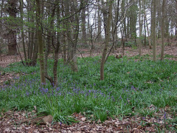

**Founded 22 January 2008: Seventh Annual Report**

There were 9 meetings of the Friends of Sharphill Wood in the year to 10 May 2016. The Annual General Meeting, postponed to 9 June 2015, elected Phil Miller (Chair), Mike Rivett (Vice Chair), Chrissie Wells (Treasurer), Jo Miller (Publicity Officer) John Elwell (Work Party Coordinator) and Bill Logan (Secretary).

There were 102 Friends on the circulation list in May 2016.

**Management developments**

A meeting was held on 12 February with Rushcliffe Borough Council to pursue mitigating measures in the light of planning permission for housing surrounding the wood. Our main concerns are that the proposed community park does not extend beyond the west of the wood, control of Section 106 monies to maintain the wood and location of the promised store facilities. At the time of writing we are making arrangements to pursue these and other issues with the developers. We have postponed meeting with Rushcliffe Borough Council and Nottinghamshire Wildlife Trust to review progress with the Management Plan and other concerns.

We continue to pursue various options for tackling path and boundary hedge maintenance, which have been undertaken at our monthly work parties. Given concerns with continuing antisocial behaviour, we have been reporting incidents to the Council and Police, which Susan Hill has been doing on a monthly basis. Sadly our notice board at the Wheatcroft end was smashed, but we have repaired this with help from a local resident who donated a replacement front.

We have agreed to work in partnership with the Skylarks reserve, which should be mutually advantageous.

We have recently begun to plan for the future by ensuring that there will be willing volunteers to carry forward our work and that what we are doing is focused on preserving the flora and fauna of the wood.

**Publicity**

Apart from investigating a replacement for our website, the year has been spent making sure it and our facebook page were dynamic and effective. Our Facebook page now has 112 people who like it and regularly view it. These people are not just from Nottingham but are from all over the world with our articles being viewed by 70+ visitors. New articles and pictures to keep interest in the Group have regularly been added. Articles for the West Bridgford Local News, outlining what we do as a Group, have frequently been published. Maintaining the website involved keeping people informed about what we are doing, requesting their input and encouraging new volunteers. The Group email box was also monitored and incoming emails forwarded to the relevant officer for action. We have regularly replaced posters in the notice boards in the wood and on local notice boards around West Bridgford showing, for example, dates of work parties and walks.

**Nottinghamshire Wildlife Trust Wildlife on your Doorstep Award**

We were unsuccessfully nominated by Ben Driver of NWT for a Nottingham Evening Post award, but were delighted that our nominee for the [South Nottinghamshire Wildlife Trust Local Group](http://www.southnottswildlife.org.uk/content/)’s Wildlife on Your Doorstep individual award, Harry Eustace, was successful.  Harry was presented with his award by Erin McDaid of Nottinghamshire Wildlife Trust at the South Notts AGM on 21 April 2016 when several of the Friends attended.

**Nature surveys**

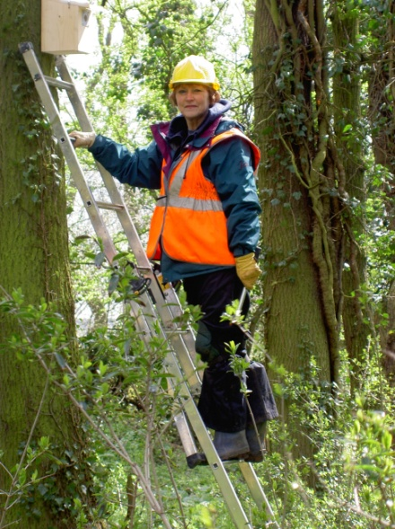

In May and June we completed the 2015 series of nest box inspections and submitted the results to the British Trust for Ornithology (BTO) Nest Record Scheme. It was a difficult year. Following good weather in April, cold weather in May affected a number of nests, and there were some late starts (probably second attempts) causing inspections to continue into July for some boxes. Of 24 tit boxes inspected, it appeared that Blue Tit and Great Tit had used only 5 successfully (compared with 9 in 2014) and a further 11 had evidence of nest building (abandoned without laying) or failed at a later stage (eggs abandoned, dead pulli and, in a couple of cases, suspected predation). Also brood sizes were very small (average 2.6 for successful nests). Four additional nest boxes, designed to attract Treecreeper, were unused. In April 2016 we carried out the first inspection for this year. An informal bird survey was carried out in May 2015. In April 2016 a Yellowhammer was seen on the hedge below the Wheatcroft entrance. This is a red-listed farmland bird not often seen in the vicinity of the wood.

**Work Parties**

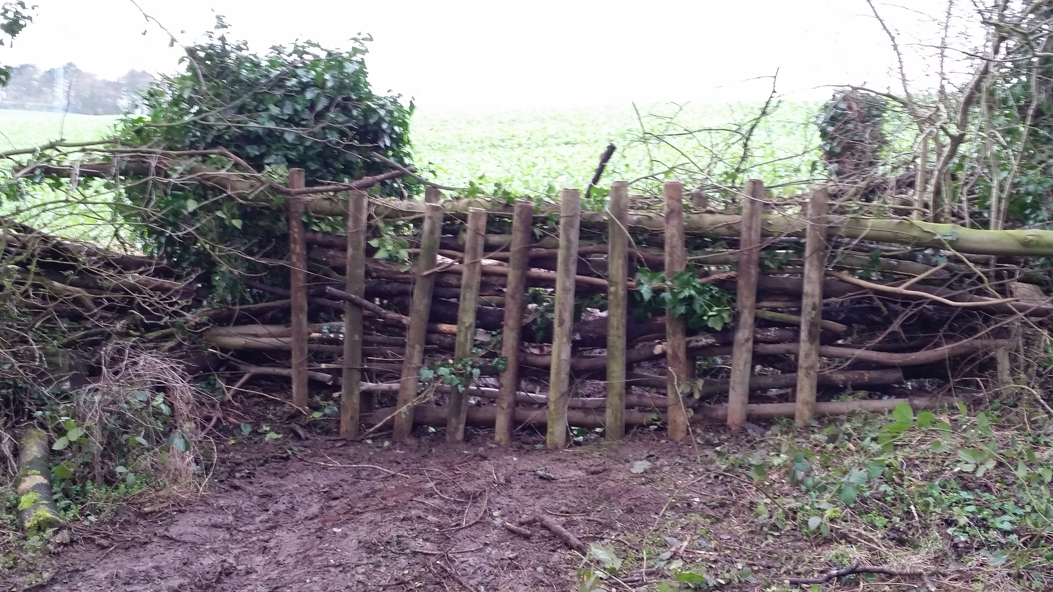During the period May 2015 to April 2016 we held 10 scheduled Sunday work parties, plus an additional work party on 11th October, when we were helped by the Meadow Covert scout troop, and a further work party in January 2016 to clean out and repair nest boxes. Including effort involved in nest box inspections in spring 2015, this amounted to approximately 500 hours of volunteers' time.

We were very fortunate with weather throughout the year, although the July work party finished early because of rain.

Much of the effort was directed at blocking boundary gaps, particularly along the western boundary. We had at our disposal a substantial number of second-hand fence posts, which were driven into the ground and used to support dead-hedging. An ongoing task has been the inspection of whips planted in previous winters, to ensure that guards and canes are in place and that they are not obstructed by weeds. A good proportion are doing well, and many of those planted several winters back are now becoming fairly substantial. In November we planted further whips, donated by the Woodland Trust, and on this occasion we were helped by scouts from the 4th West Bridgford troop. In January we planted yet more, this time donated by TCV, and on some occasions whips grown by Friends from seeds from the wood were planted, including a number of oaks. Other tasks included distributing stones to muddy sections of the paths, treating the ladder boards with linseed oil, clearing fallen branches, Sycamore removal, litter picking (particularly from party sites), maintenance work in the vicinity of the pipe under the "swamp of doom", trimming encroaching vegetation along the main path, and planting native bluebell bulbs in a bare area not far from the present area of bluebells.

**Community participation**

We continue to encourage public understanding and awareness of issues relating to the site by making presentations to local groups. In January we made a presentation to the West Bridgford U3A Gardening Group and we are grateful for their £40 Donation. In March we gave a presentation to enthusiastic pupils at Willow Brook School, Keyworth.

We also held our regular community walks over the last year.  It was agreed that the Christmas Social had been a success as usual. The Boxing Day walk had a fairly low turnout and it was agreed to consider an afternoon kick off this year.

 We also held our annual walk on 27th March, which was well supported by the community and we picked up some new volunteers.

**Finance**

The total asset balance at the year-end was £1044.46. Of that, unrestricted funds amount to £94.39. Our main requirements during the year were for path and boundary maintenance, however we refreshed our first aid kit following First Aid Training for several volunteers. We also planted some new English Bluebells. Our requirements were well covered by donations from our kind supporters. Rushcliffe Borough Council is to provide funding for gravel with which we have dressed the paths to try to minimise the mud problem. This is shown as a note to the accounts. Nottinghamshire and Rushcliffe councillors provided funding for boundary work, insurance and membership of the Trust for Conservation Volunteers. These funds are shown as restricted. West Bridgford U3A Gardening Group gave a donation of £40.00, whilst a donation of £30 was received from John Krafts for planting an oak in memory of his brother Simon.

Mr. and Mrs. Frank Collins graciously continued to provide funding in kind by offering their home for our regular meetings.

These donors are thanked profusely for their kind contributions.

**Acknowledgements**

The Group would once again like to thank Nottinghamshire Wildlife Trust, especially Ben Driver, Paul Phillips of Rushcliffe Borough Council and Gordon Dyne of the South Notts Group for their continued advice and support. Also, thanks to the many volunteers who helped at our work parties.

Phil Miller (Chair), Mike Rivett (Vice Chair), Chrissie Wells (Treasurer), Jo Miller (Publicity Officer), John Elwell (Work Party Coordinator) and Bill Logan (Secretary).